**Guidance Utility for Impaired Daily Experiences (GUIDE)**



*Final Report*

GUIDE

Alyan Tharani

Jack Couture

Jack Letsinger

Noah Kilpatrick

Ryan Wu

Diana Canchola

Department of Computer Science and Engineering

Texas A&M University

12/03/2024

Table of Contents

1 Executive summary 2

2 Project background 5

2.1 Needs statement 5

2.2 Goal and objectives 5

2.3 Design constraints and feasibility 5

2.4 Literature and technical survey 6

2.5 Evaluation of alternative solutions 8

3 Final design 10

3.1 System description 10

3.1.1 Hardware 11

3.2 Approach for design validation 25

4 Implementation notes 27

Hardware Components 27

Functions and Their Roles 45

5 Experimental results 54

6 User’s Manuals 61

6.1 Hardware Installation 62

6.2 Software Installation 65

6.3 Operation Instructions 65

7 Course debriefing 67

8 Budgets 69

9 Appendices 72

10 References 72

# Executive summary

As you did with the proposal, the final report should start with an executive summary. In this section, you provide a brief overview of (1) the need, goal and objectives of the project, (2) the final design and implementation, (3) the results that were obtained, and (4) your experiences with team/project management. The intended audience of the executive summary is the program director at the institution/company that funded your project. Since the executive summary is a summary of the final report, it should be written last.

Ever since the creation of the walking stick in 1947, there has been little innovation for the visually impaired to better navigate their surroundings. Over 200 million people suffer from visual impairment, with over 50 million being classified as fully blind. The environment that these people navigate through daily is constantly changing, and the ability for the walking stick to detect the user’s surroundings is limited.

GUIDE, short for Guided Utility for Impaired Daily Experiences, aims to improve the detection of objects in the environment by utilizing LiDAR sensors and depth perception technology to calculate the distance of an object from the user, and to provide a vibration on the handle of the walking stick. This vibration varies in strength depending on the distance of the object, with closer objects providing a stronger vibration.

The information collected by the sensor and camera is then sent to a Raspberry Pi Pico 2 that utilizes software designed to determine whether the object detected is tangible. The Pi serves as the product’s microcontroller, transferring and computing data from the sensors to the rumblers. This data is then used to send out a vibration of varying strength depending on object distance. A small battery is included to power the hardware, and is replaceable with a 3-4 hour battery life.

To achieve this goal, the LiDAR sensor and depth perception camera work together to produce clearer data for the software engine to process, ultimately providing accurate vibration strength for the user. The depth camera scans the surrounding environment in a cone-like shape and provides detailed depth information in three dimensions. The LiDAR builds on this by using high precision scans to detect objects within the user’s range. The data from both sensors is then processed by the Raspberry Pi Pico and depending on the range of the object detected, a combination of vibration sensors is activated, with closer ranges causing stronger vibrations.

In addition to the Raspberry Pi Pico 2, there are several hardware components that contributed to the success of this project. The BOANV 1300mAH 9V Rechargeable Battery provides power to the cane, and the 12V DC Toggle Switch and EBOOT DC-DC Buck Converter assists in managing the power distributed throughout the hardware to ensure voltage levels would not overload the components. All components excluding the LiDAR and depth camera are stored in a 3D printed handle, while the LiDAR and depth camera are both mounted onto the stick utilizing 3D printing and an angle adjuster.

GUIDE has been tested to ensure that it meets three crucial validation procedures. Obstacle detection must have a range of 2 meters, the total weight must be between 1.5 and 2 pounds, and the haptic response from the vibration sensors must occur within 0.5 seconds. Testing results show that GUIDE clears all of these requirements, as it is programmed to detect within 2 meters, weighs 1.8 pounds, and has latency ranging from 9.97 ms to 44.14 ms depending on depth camera readings. GUIDE is also affordable, as components were chosen in a manner to prioritize cost efficiency, with the budget of a prototype being around $170, with a realistic product pricing much lower due to purchasing from internal vendors.

Multiple tests were conducted utilizing GUIDE to confirm functionality in different environmental settings. Two tests were conducted in a classroom setting, one for stationary objects and another for objects in motion. Another two tests were conducted outdoors on Texas A&M University’s campus, the difference between the two tests being the density of obstacles and people. Utilizing GUIDE in these environments returned positive results, with consistent detection accuracy and latency being measured across every test environment. Testing in dark environments alongside different weather conditions was considered, however due to IR detection from the sensors it was determined to be unnecessary. This shows that GUIDE is capable of functioning in a variety of environments.

Team management was organized in a traditional manner, with Diana as team leader and software support, Jack L as hardware lead, Jack C as software lead, Ryan as hardware support, Alyan as hardware support, and Noah as software support. This organizational structure was efficient and flexible, although this is due in part to team members participating in overarching discussions of the project and its direction. Each team member was made aware of progress in each category, which was necessary due to the combination of hardware and software needed to provide GUIDE its features and functionality.

# Project background

## Needs statement

The visually impaired population makes up around 285 million people all over the world, 50 million of which are completely blind according to the World Health Organization. Although there have been many innovations to accessibility and our infrastructure, it remains difficult to navigate certain environments such as university campuses. The current limitations for the visually impaired include the inability to detect obstacles in front of them and the distances of those obstacles. Knowing these two pieces of information can better aid the visually impaired in navigating college campuses, making higher education more accessible. The current solution involves static walking sticks that can signal the visually impaired if an obstacle is in front of them when the stick touches the obstacle. This design became collapsible but has not seen any other major changes since 1947. With the technology available today, the walking stick is in desperate need of an overhaul to allow users to have a better understanding of what the terrain is like and what is ahead of them rather than only knowing what the stick has touched.

## Goal and objectives

GUIDE is geared towards visually impaired individuals, serving as a means to detect obstacles and to provide feedback to the user to alert them of their surroundings. Through depth detection connected to a vibrating handle, GUIDE will inform the user of their surroundings and any obstacles in their way as well as the relative distance from the obstacle. It will allow for changing sensitivity to allow the user to have more control over their experience. GUIDE will provide real-time feedback with delays of less than 0.5 seconds to its users. It will allow for different metrics to be modified so users can tune the performance to their needs and wants. GUIDE will use a depth camera and LiDAR working in combination to detect obstacles 2 meters away and provide real-time feedback, allowing visually impaired users to navigate safely and independently in various environments. GUIDE will use affordable, high-quality parts and materials, and will not exceed the budget of $300. The design will not be intended to be replaced, but rather last as long as the warranties of the parts allow. GUIDE will be powered by commercially available batteries that can be replaced when out of charge with a battery life of 3-4 hours. In the event of a future iteration, it should include charging capabilities. GUIDE will be able to operate at any time of day, as well as both indoors and outdoors. While not completely submersible, it will be able to withstand small amounts of water in the event of rain or spills.

## Design constraints and feasibility

A major constraint as mentioned previously is the power supply. GUIDE will have to have the batteries manually replaced following a 3-4 hour use window. This is due to factors such as cost as well as structure. The current power supply is very cheap and easy to work with whereas a charging setup with a port can become very expensive very fast in order to fully implement. The $300 budget would instead be better spent on better LiDAR and other technologies that can improve the functionality of the device. Furthermore, having a charging set up in the walking stick or its handle leaves little room for other critical devices such as the vibrator motors and their wiring. So, to implement this, the walking stick would need to have an even larger handle and larger diameter of the stick, completely changing the structure of GUIDE. Thus, the objectives and goals we have set have focused on feasibility within the budget as well as ensuring the complexity does not exceed the amount of time we have to work with. Overall, the only other major constraint is the cost of technologies such as LiDAR. As mentioned, that is where we have decided to place most of our budget. This is because LiDARs are usually fairly expensive and with our budget, we cannot afford a top-of-the-line LiDAR. However, for this project to be feasible, we do need a LiDAR that can work efficiently and consistently in our system which is why it is a large chunk of our budget. With a larger budget, we could acquire a better LiDAR and maybe a better depth camera, but the project is still very much feasible under budget constraints.

## Literature and technical survey

Lazarillo (Smartphone-based Navigation Apps)

For the first review, we chose to look at Lazarillo[2], a GPS App marketing itself as free and accessible for the blind and visually impaired. While a promising solution that has no additional equipment to carry, the main issue was a lack of location updates.

Pros:

* Widely accessible, most people already own smartphones
* Can leverage existing GPS and mapping technology
* Easy to update and improve software

Cons

* Requires users to hold or wear their phone constantly
* May not provide precise enough guidance for close-range tasks
* Battery life concerns for all day use.

Obstacle Detection in Infrared Navigation for Blind People and Mobile Robots (Infrared Sensor for Object Detection)

A research paper from Robotic Systems and Automatic Control: Mathematical Models, Technologies, Applications and Challenges[4] proposes an infrared-based navigation system for blind individuals and mobile robots, capable of detecting obstacles like corners in indoor environments. The system utilizes temperature differences near wall corners, providing a low-energy solution that doesn’t require additional equipment beyond a small infrared camera.

Pros:

* Low power consumption
* Can work in low light conditions
* Lower cost compared to conventional computer vision systems

Cons

* Limited range and accuracy
* Cannot provide information about object type or colors
* may struggle with certain materials that don't reflect infrared light well

NaviBelt (Bag/Belt Attachment with Cane)

The NaviBelt[5] is a wearable device with 16 vibration units, which “guide” you to either to true North or your destination. NaviBelt is barrier free with no handling, and even provides increased spatial awareness benefits to those without vision impairments. While it does improve orientation, it appears to be optimal when supplemented by traditional devices such as a white cane.

Pros:

* Hands-free design
* Benefits of navigation to non-impaired users
* Smartphone connectivity

Cons

* Forced to “wear” the product, regardless of personal dress and fitness habits
* Potential weight or uncomfortableness when running or walking at accelerated speeds
* Battery life

SPOT walking robot with camera (Camera Object Recognition)

SPOT[6], similar to the Boston Dynamics robot, is an all 4-legged autonomous robot that can perform security patrols, take measurements, or even assist visually impaired people with its camera. Similar to a guide dog, SPOT could be programmed to “see” for its user by walking ahead and warning / describing the environment.

Pros:

* Hands free, separate robot
* Can ‘act’ as a seeing eye dog, be of assistance in ways beyond visual guidance

Cons

* Extremely low battery life
* Large and potentially disruptive in delicate environments
* Extremely expensive

Wewalk (AI integrated smart cane)

Wewalk[7], a smart cane offering AI features such as GPT integration, is a cane that has been in development since 2011. It claims to have enhanced obstacle detection, provide an intelligent voice assistant, accessible navigation, as well as the ability to discover public transit live.

Pros:

* Cutting edge AI technology
* Access to public transit
* Voice assistant support and phone connectivity

Cons

* On backorder for 5+ years
* Over promised on features, no product shipped to date
* Constant need for internet access

Our research has concluded that GUIDE poses some unique advantages, such as not needing a phone like Lazarillo. Unlike typical infrared-based systems, GUIDE uses both a LiDAR and a depth camera, potentially offering more detailed and accurate obstacle detection. Compared to NaviBelt, GUIDE does not require the user to wear any additional equipment, making it less intrusive. While not technically advanced as an AI-powered robot solution like SPOT, GUIDE is significantly more affordable and portable. Finally, in contrast to products such as WeWalk, GUIDE aims to be a more immediately realizable solution using readily available components.

While GUIDE may not offer some of the advanced features of AI-powered or smartphone-integrated solutions, it targets a niche that prioritizes practical, reliable, and affordable assistance for daily navigation tasks. Its focus on enhancing rather than replacing the traditional white cane sets it apart as a solution that respects existing habits while providing meaningful technological improvements.

## Evaluation of alternative solutions

Alternative Solution 1: Phone Application with Audio

This solution involved object detection and alert via a smartphone application which would audibly output the obstacles ahead of the user. The application would allow the user to edit the settings of the device as well as connect headphones to hear the alerts or play them outloud.

Pros

* The application gives the user a central, customizable interface with the device.

Cons

* Audio cues could audibly impair the users as well as surrounding people.
* Audio cues could be hard to understand or hear in loud environments, particularly college campuses.

Alternative Solution 2: SLAM Algorithm to Add Obstacles to Database

This solution involved adding an additional feature, a database containing obstacles. The cane would have GPS capabilities and keep track of obstacles encountered by adding them to a database. This database would help the algorithm detect accurately if there were any obstacles in front of the user.

Pros

* The database allows the software to rely on the sensors and previous information.

Cons

* The database and collection of data are a stretch goal, they prove time consuming.

Alternative Solution 3: Infrared Sensor for Object Detection

The use of an infrared sensor for obstacle detection was floated by the team when brainstorming what hardware and electronics would work best given our elected environment.

Pros

* The IR sensor adds visibility to the software and can help paint a better picture of the environment.

Cons

* The device must cover 2m of distance and function in all temperatures, the IR sensor is not best suited for this.

Alternative Solution 4: Bag/Belt Attachment with Cane

This solution included adding a wearable belt/bag with the battery and wires to store the device hardware.

Pros

* The attachment allows a means to store equipment for the cane.

Cons

* The added accessory can be cumbersome for the user to carry.

Alternative Solution 5: Camera Object Recognition

This solution adds functionality to the object detection by deducing what obstacle is in front of them in addition to the distance.

Pros

* This solution gives the user a better idea of their environment and what is physically in front of them.

Cons

* Due to time constraints and budget we elected to keep the detection simple.

# Final design

## System description

Raspberry Pi Pico

The Raspberry Pi Pico serves as the central processing unit of the GUIDE system. It’s responsible for integrating data from various sensors, processing the information, and controlling the output devices. The Pico’s dual-core ARM Cortex-M0+ processor provides sufficient computational power to handle real time data processing from the LiDAR and depth camera. It also manages the communication between different components and executes the algorithms that determine when and how to alert the user about obstacles.

9V Battery

The 9V battery is the primary power source for the GUIDE system. It provides the necessary voltages to power all the components, including the Raspberry Pi Pico, sensors, and buzzers. The choice of a 9V battery offers a good balance between power capacity and size, allowing for a compact design while ensuring sufficient operating time for the device.

Buck Converter

The buck converter plays a crucial role in power management and transformation in the GUIDE system. It steps down the 9V voltage from the battery to the appropriate voltage levels required by the components. This voltage reduction ensures stable and efficient power delivery to all parts of the system, preventing damage to sensitive electronics from voltage fluctuations.

Buzzer

The buzzer is the primary output device in the GUIDE system. It provides tactile feedback to the user about detected obstacles. The buzzer can emit different intensities or patterns of vibration to convey information about the distance and nature of the obstacles. This feedback is crucial for users with visual impairments who rely on non-visual cues for navigation.

Depth Camera

The depth camera is a key sensor in the GUIDE system, providing detailed 3D information about the environment in front of the user. It captures depth data, allowing the system to create a three-dimensional map of the surroundings. This information is crucial for detecting obstacles, understanding their size and shape, and determining their distance from the user. The depth camera's data is processed by the Raspberry Pi Pico to provide accurate and detailed obstacle detection.

LiDAR

The LiDAR (Light Detection and Ranging) sensor complements the depth camera by providing highly accurate distance measurements. It uses laser light to measure the distance to objects with high precision. In the GUIDE system, the LiDAR data is used in conjunction with the depth camera data to create a more robust and accurate obstacle detection system. The LiDAR is particularly useful for detecting obstacles at longer ranges and in various lighting conditions.

3D Printed Handle and Housing

While not electronic components, the 3D-printed handle and sensor housing are integral parts of the GUIDE system. The handle ergonomically houses the Raspberry Pi Pico, battery, buck converter, and buzzers. It's designed for comfort and ease of use, allowing the user to easily grip and manipulate the device. The sensor housing securely holds and protects the LiDAR and depth camera, ensuring they maintain proper alignment for accurate obstacle detection.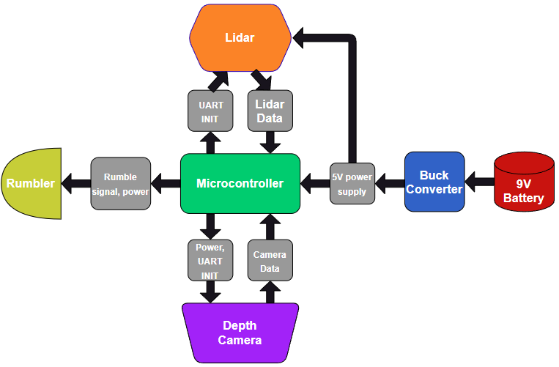

***Figure 1:*** *The diagram above shows the hardware breakdown and implementation of all hardware components in GUIDE.*

Complete module-wise specifications

## Hardware

**Circuit and logic diagrams**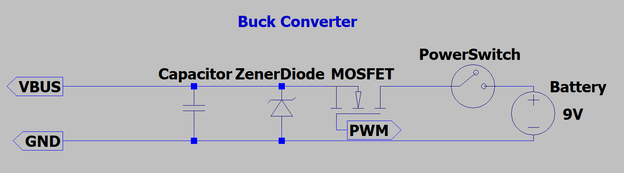

***Figure 2:*** *Circuit diagram of the Buck Converter utilized by GUIDE system.*

***Figure 3:*** *Circuit diagram of Raspberry Pi Pico*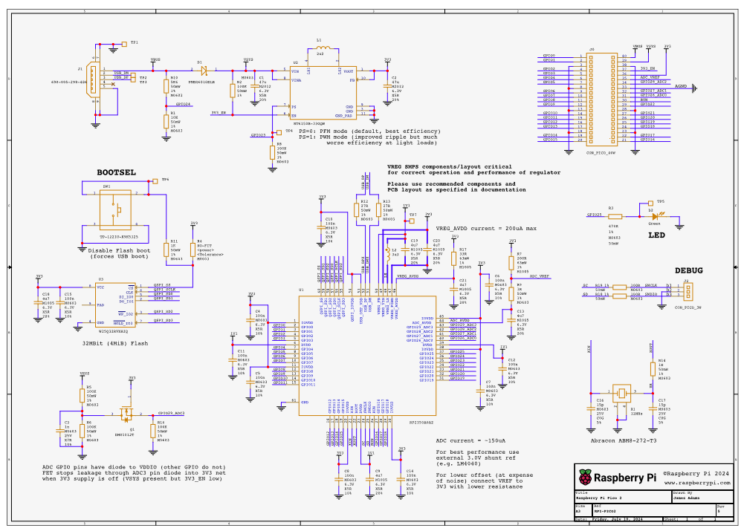

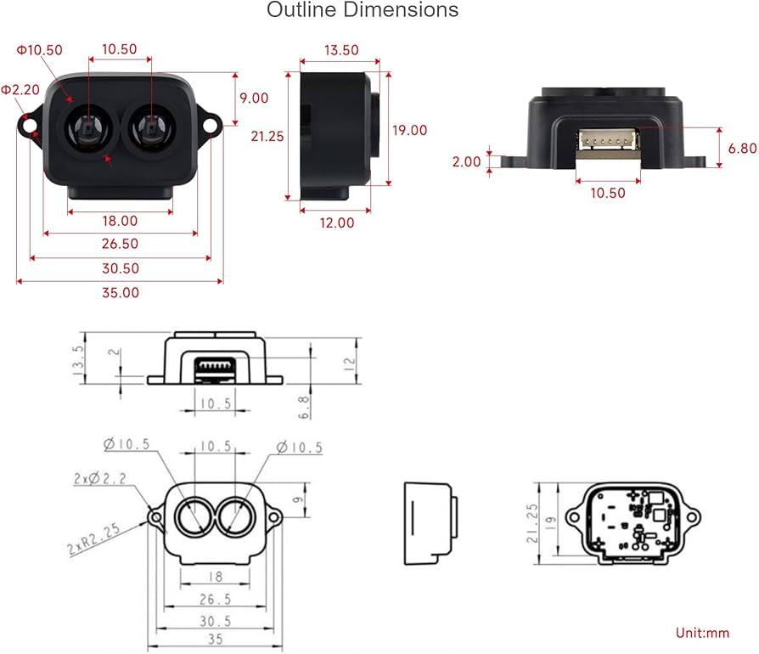

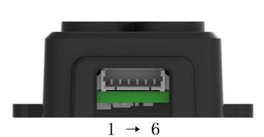

***Figure 4&5:*** *The figures above show screenshots of the LiDAR datasheet with measurements as well as wire connections.*

***Table 1:*** *The table above shows the breakdown of wire connections of the LiDAR.*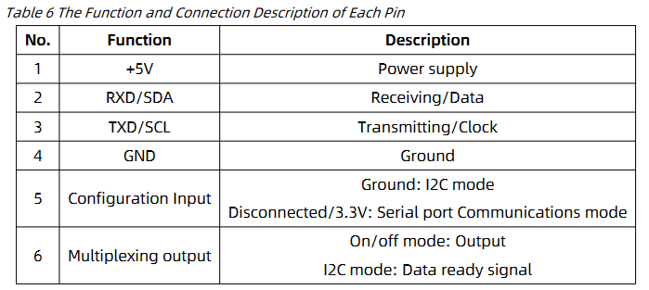

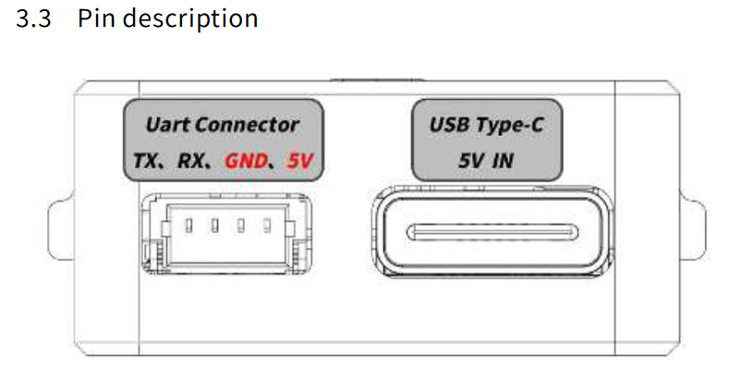

***Figure 6:*** *Side rendering of the Depth Camera including UART connections and USB-C connection.*

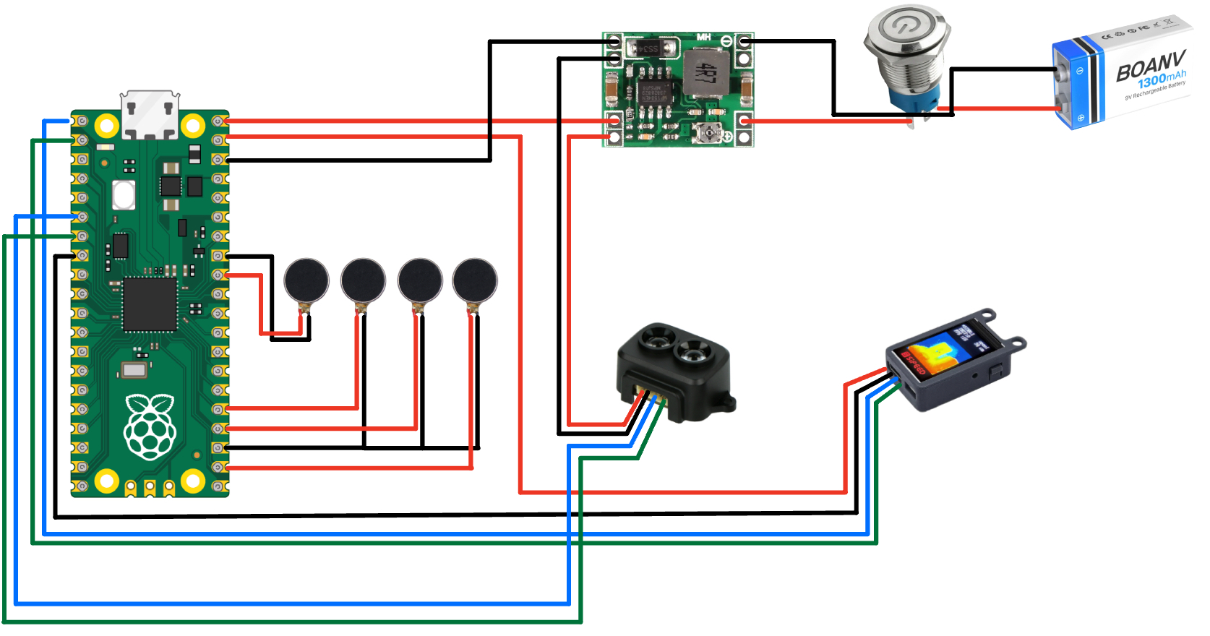











***Figure 7:*** *Pinout diagram of GUIDE system. The system includes the microcontroller, the Raspberry Pi Pico, the electronic sensors, LiDAR and depth camera, the power distribution modules such as the battery and buck converter, and finally, the power button.*

**Timing diagrams and waveforms**

The response time of the sensors is a critical part of this project. Our initial target reaction time of 0.5 seconds (500ms) from the proposal was generous, and current data collection testing indicates that we will be well within the specification.

|  | No Lidar | Lidar |
| --- | --- | --- |
| No Depth Camera | N/A | 9.97 ms |
| Depth Camera | 21.98 ms | 44.14 ms |

***Table 2:***  *This table outlines the response times of the LiDAR sensor and Depth Camera.*

It is interesting to note that the LiDAR had an average faster response time. Additionally, both sensors had a little to no response variation, with the depth camera ranging between 19 and 25 ms, and lidar ranging between 8 and 11 ms when tested individually. However, having both sensors collecting data at once (with limited cpu resources), makes the average data response around 44ms. Assuming a worst case scenario of 50 ms response time, this is still 10x faster than the proposed number.

While this testing is valid and within spec, these timings include the time needed to print out the telemetry data. Print statements and if/else statements in the program logic can eat up time and resources, so disabling them in the final build will probably allow for an untestable but respectable performance boost.

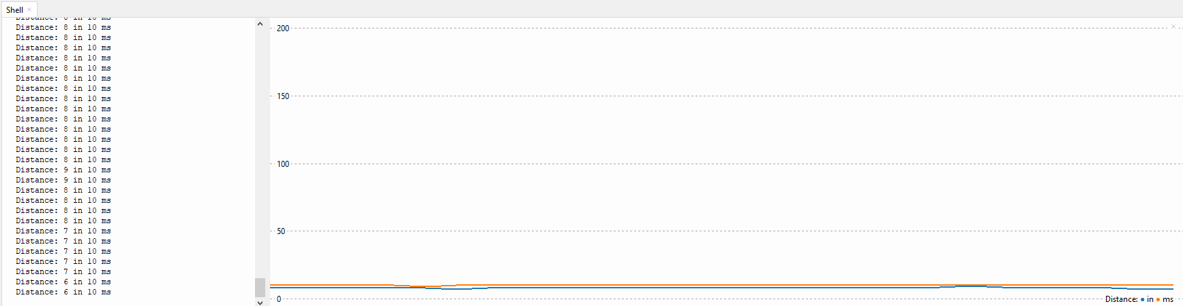

Object distance from Lidar and response time in milliseconds as a function of time.

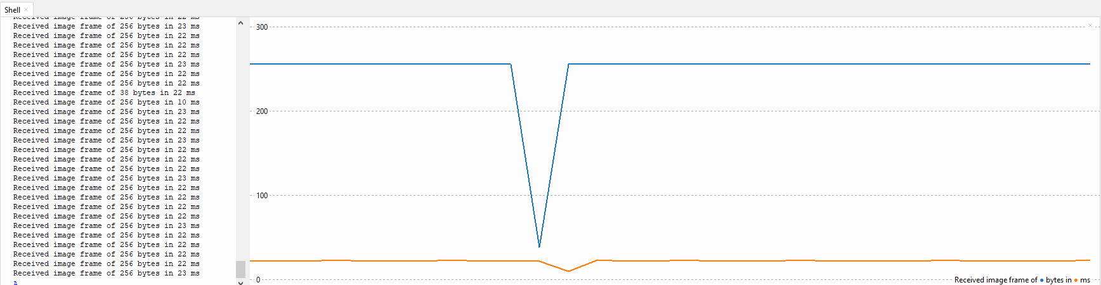

Packet Size from Depth Camera and response time in milliseconds as a function of time.

As per the graph, all feedback is internally relayed and output via a LED/Buzzer within the handle. The timings are very consistent, with dips or dropped bytes being only a result of the tail end of a packet from one of the sensors.

**Software processes with their inputs and outputs**

Here is the current source code implementation:

from machine import UART, Pin

import utime

import struct

led = machine.Pin(25, machine.Pin.OUT)

buzzer = machine.Pin(15, machine.Pin.OUT)

# Initialize UART on GP0 (TX) and GP1 (RX)

uart0 = UART(0, baudrate=115200, tx=Pin(0), rx=Pin(1)) # LiDAR

uart1 = UART(1, baudrate=115200, tx=Pin(4), rx=Pin(5)) # Depth Camera

Here is the initialization of both UART ports on the Pi. While the Pico has 2 UART ports that can be wired up in 5 different locations, each sensor needs to be on a different UART channel in order to prevent data miscommunication.

There are still a few parameters of the UART class from the machine library that will be worth going through in order to make the project more accurate and power efficient.

def send_at_command(command): # send configuration settings to the depth camera

uart1.write(command + '\r')

utime.sleep_ms(100) # Wait for response

response = b''

if uart1.any():

response += uart1.read()

print(f"Command: {command}, Response: {response}")

return response

def initialize_camera():

send_at_command("AT+ISP=1") # Turn on ISP

send_at_command("AT+DISP=4") # Enable UART display

send_at_command("AT+SAVE=1")

Here is the depth camera initialization and communication protocol. As per the documentation, several settings must be enabled and saved to ensure the camera is working properly. The UART Python class makes this exceptionally readable and easy to implement. The print statements will be taken out of the final build, as it will not be readable. Note that there is No LiDAR setup function, as it is by default in the correct configuration and requires no changes.

def read_lidar():

try:

if uart0.any():

data = uart0.read()

if len(data) >= 7 and data.startswith(b'YY'):

distance = struct.unpack('<H', data[2:4])[0]

print(f"Distance: {distance}", end=" ")

return distance

else:

print("Incomplete or invalid frame")

return None

except Exception as e:

print(f"Error: {e}")

return None

return None

def read_camera():

try:

if uart1.any():

data = uart1.read(256)

print(f"Received image frame of {len(data)} bytes", end=" ")

return data

except Exception as e:

print(f"Error: {e}")

return None

Here are the lidar and depth camera read functions. For the LiDAR, the exact bytes that determine distance have been figured out and are decoded every function loop. While we understand how to process the Depth Camera data over the UART, the software implementation in python has not yet occurred, as it was not necessary for the full proof of concept for the breadboard prototype.

print("Initializing camera...")

initialize_camera()

# Main loop

while True:

try:

distance = read_lidar()

if distance is not None:

if distance < 100:

led.value(1)

buzzer.value(1) # Turn on the buzzer when LED is on

else:

led.value(0)

buzzer.value(0) # Turn off the buzzer when LED is off

image_frame = read_camera()

except Exception as e:

print(f"Error: {e}")

As previously mentioned, while the camera data can be properly configured and read, we are still in the implementation phase of utilizing it as intended. With the setup of the GPIO pins in the header, toggling the values of an LED or Buzzer as a result of incoming data is clear and easy to implement. While using C or C++ would result in improved memory and power consumption, as well as better performance, the ease of python as an interpreted language and high level of abstraction make it easy to debug and prototype the sensors, with suitable performance as a tradeoff. If we were to discover that a python or non-C approach was too slow, we would approach the project differently and make changes as needed.

Example data coming from LiDAR:

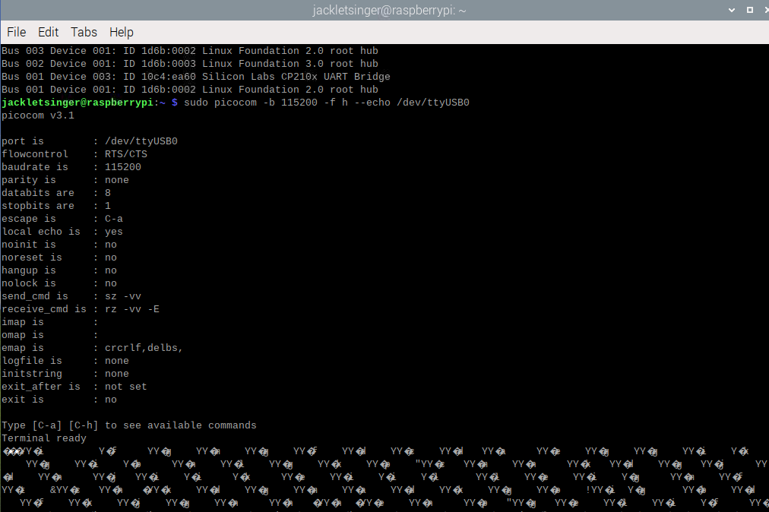

Initial data coming from the LiDAR through a UART bridge to a Linux machine was not promising. Data would arrive in inconsiderate bursts, with null and undefined ASCII characters in and around data packets. This made it difficult for our software team to get a foothold on the data gathering component of the project.

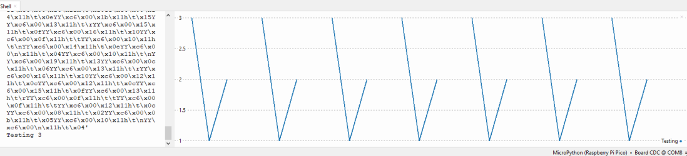

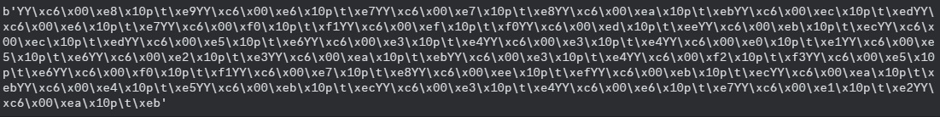

Despite issues running connected to a computer, the LiDAR worked perfectly on the Pi Pico.

Example data coming from Depth Camera

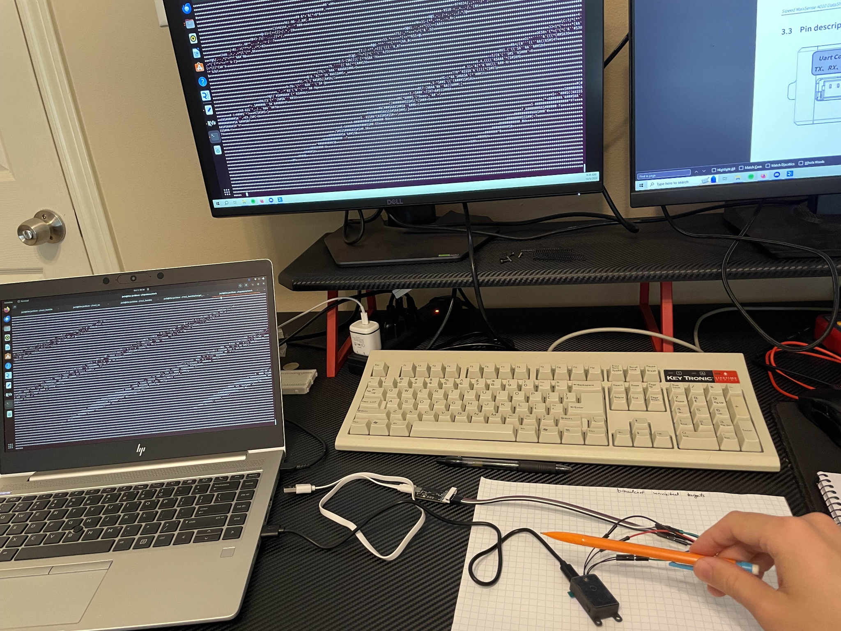

***Figure 8:*** *Early stages of Depth Camera development before decoding data packets.*

The Depth Camera has a LCD display that shows a heatmap of the image it takes in, as well as the frame rate. The Data piped through the Pi however is an ASCII representation of the image, with a header that could potentially indicate a distance and other useful telemetry for this project.

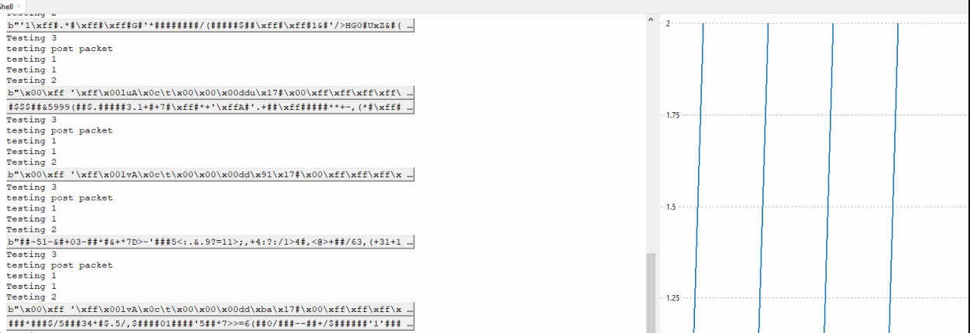

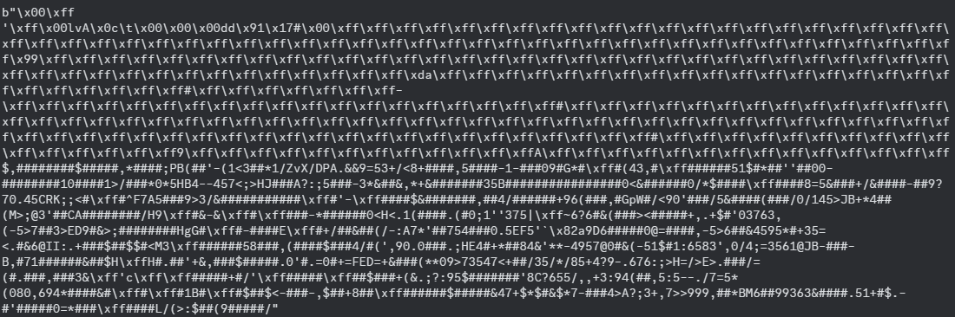

GUIDE Parts List

|  | Amount | Amount per Unit | Cost per Unit | Dimensions | Weight | Total Amount ($) |
| --- | --- | --- | --- | --- | --- | --- |
| Walking Stick | 1 | 1 | $17.99 | 53in x 0.5in - Rod  7in x 1in - Handle | 0.55lb | $17.99 |
| Power Button | 1 | 1 | $9.99 | 16mm | 0.35 ounces | $9.99 |
| Vibrating Motor | 2 | 8 | $7.59 | 10mm x 2.7mm | 0.63 ounces | $7.59 |
| LiDAR | 1 | 1 | $23.99 | 10mm x 2.7mm | 0.176 ounces | $23.99 |
| Depth Camera | 1 | 1 | $43.00 | 10mm x 2.7mm | 10.6 ounces | $43.00 |
| Buck Converter | 1 | 6 | $1.67 | 22mm x 17 mm | 3g | $10 |
| Raspberry Pi Pico 2 | 2 | 2 | $6.25 | 21mm x 51mm | 4g | $12.50 |
| 9V Battery Holder | 1 | 10 | $0.50 | 0.94"L x 0.47"W x 0.28"H | <1g | $4.99 |
| 9V Battery (Rechargeable) | 1 | 4 | $5.25 | 48.8mm x 26.0mm | 0.12kg | $20.99 |
| PLA Printer Filament | 1 | 1 | $0.055 (per g) | N/A | 63g | $3.50 |
| Angle Adjuster | 1 | 1 | $13.99 | 2.95” x 2.56” x 0.98” | 0.09kg | $13.99 |
| Total (s) | N/A | N/A | N/A | N/A | 44.72 oz or 2.795 pounds | $168.53 |

***Table 3:*** *Completed list of parts ordered for GUIDE.*

* + 1. Software

The software systems in place read a CSV file collected by the depth camera or the LiDAR and take the hex bytes to convert the data into standard assignments. This involves taking in a collection of bytes and deciphering the header and any data relevant to the capture device such as distance in different axes and other provided data. The software converts this hex to integers so that the values can be easily understood and manipulated using standard integer calculation rather than trying to work in hex. Originally, this data was then pieced together into frames in order to recreate what the capture device was seeing. However, this data will be collected and compared to determine which capture device is more accurate in different situations. The plan is to have an artificial intelligence system and machine learning that has been fed data from both capturing systems as well as the measured distances so that it can determine when to use the distance from which device or determine an algorithm that works best. This could involve a weighted average with the depth camera or LiDAR being considered more accurate in certain situations. For now, we are focused on moving the software onto the actual device and running it with live data. This will involve taking in the bytes in real-time and simply determining the distance. Finally, we originally were using C++, but with recent hardware changes, all code moving forward will be in Python with any remaining C++ scripts being rewritten. Below are two examples of important functions in our code that will be converted to Python and implemented using Python libraries rather than C++:

for (int i = 0; i < 16; i++) {

std::getline(ss, byte, ',');

int value = hexToInt(byte); // Convert hex string to integer

row_data.push_back(value);

}

This code is used to actually read from Byte0 to Byte15 with a line in a previous part of the code skipping the first byte as that is the header. These bytes contain critical information such as distance in the axes and image data that can be used for calculations as well as generating images or video. It also calls another important function that is shown below:  
  
int hexToInt(const std::string& hexStr) {

int value;

std::stringstream ss;

ss << std::hex << hexStr;

ss >> value;

return

This simple function takes in the hex data and converts it to an integer when called so that the value may be more easily manipulated and understood as mentioned before. Overall, these two functions drive a lot of the basic but very important processes when receiving data with the LiDAR or the depth camera and we hope to have a system in place to allow both capture devices to work together as soon as possible.

* + 1. 3D Modeling

|  | Amount | Amount per Unit | Cost per Unit | Total Amount ($) |
| --- | --- | --- | --- | --- |
| PLA Printer Filament (Testing/Final) | 800g | 800 | $0.055 (per g) | $40 |

***Table 4:*** *3D printing prices for GUIDE handle.*

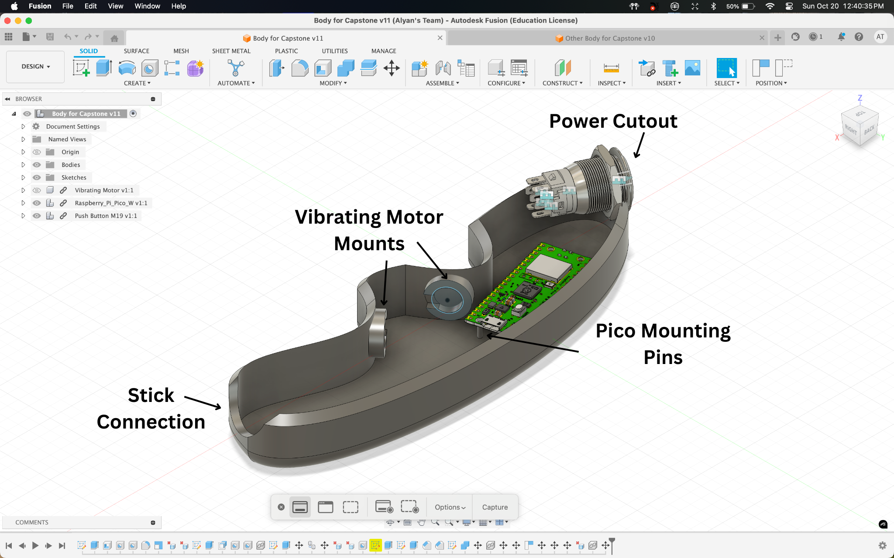

***Figure 9:*** *CAD for left side of handle body. This body includes pins for Raspberry Pi Pico Mounting, cutouts for power button and stick connection, and there are also cutouts for 2 vibrating motors. Further, this is a mirror copy of the right side, and we have printed out an example print shown in Figure 10-11.*

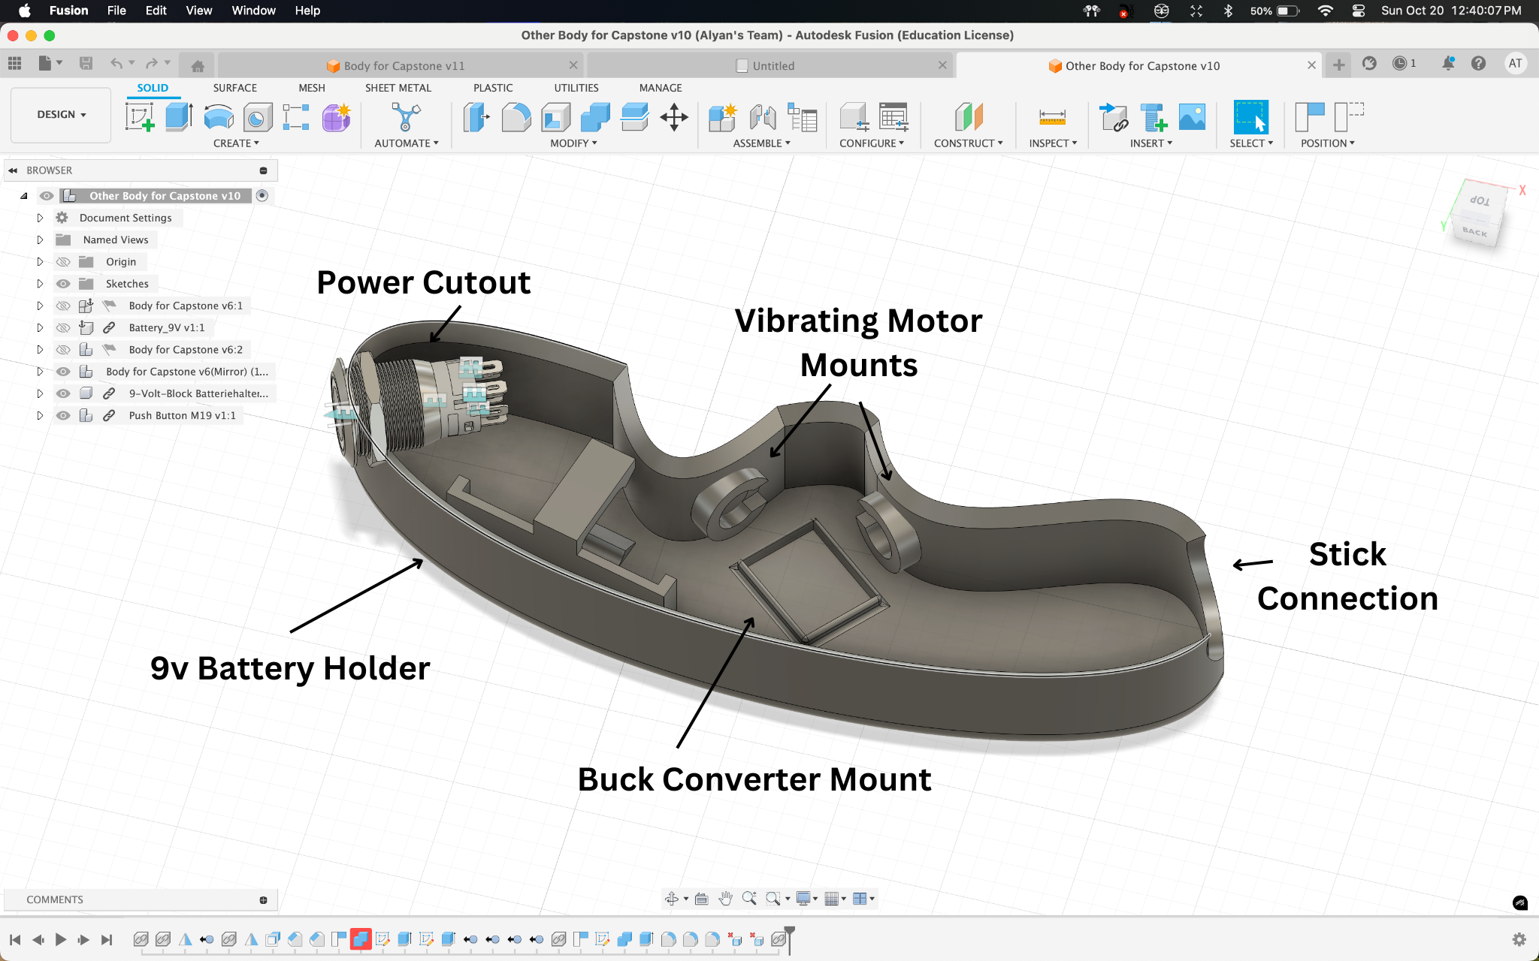

***Figure 10:*** *CAD for right side of handle body. This body includes a mount for the Buck converter which allows us to drop the voltage from the 9v battery to 5v. It also includes a battery mount, two vibrating motor mounts, and cutouts for the walking cane* connection and a power button cutout. Further, this is a mirror copy of the right side, and we have printed out an example print shown in *Figure 10-11.*

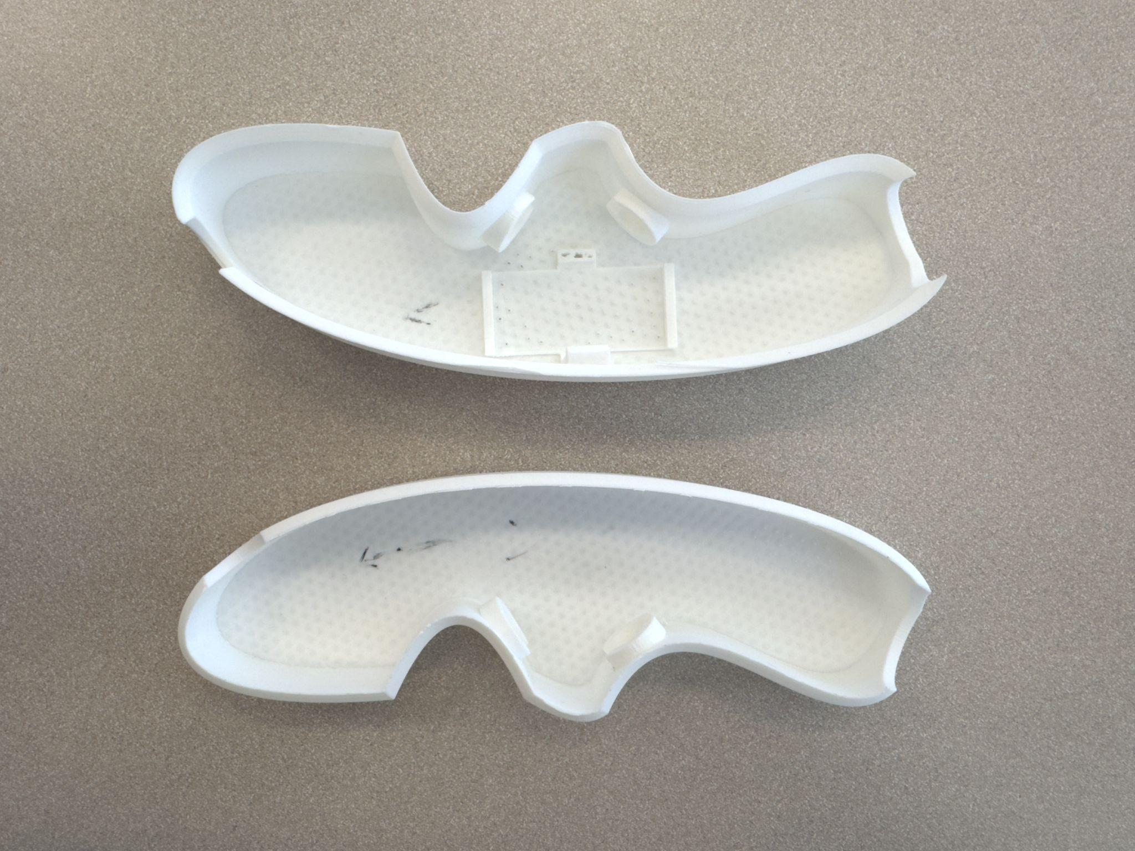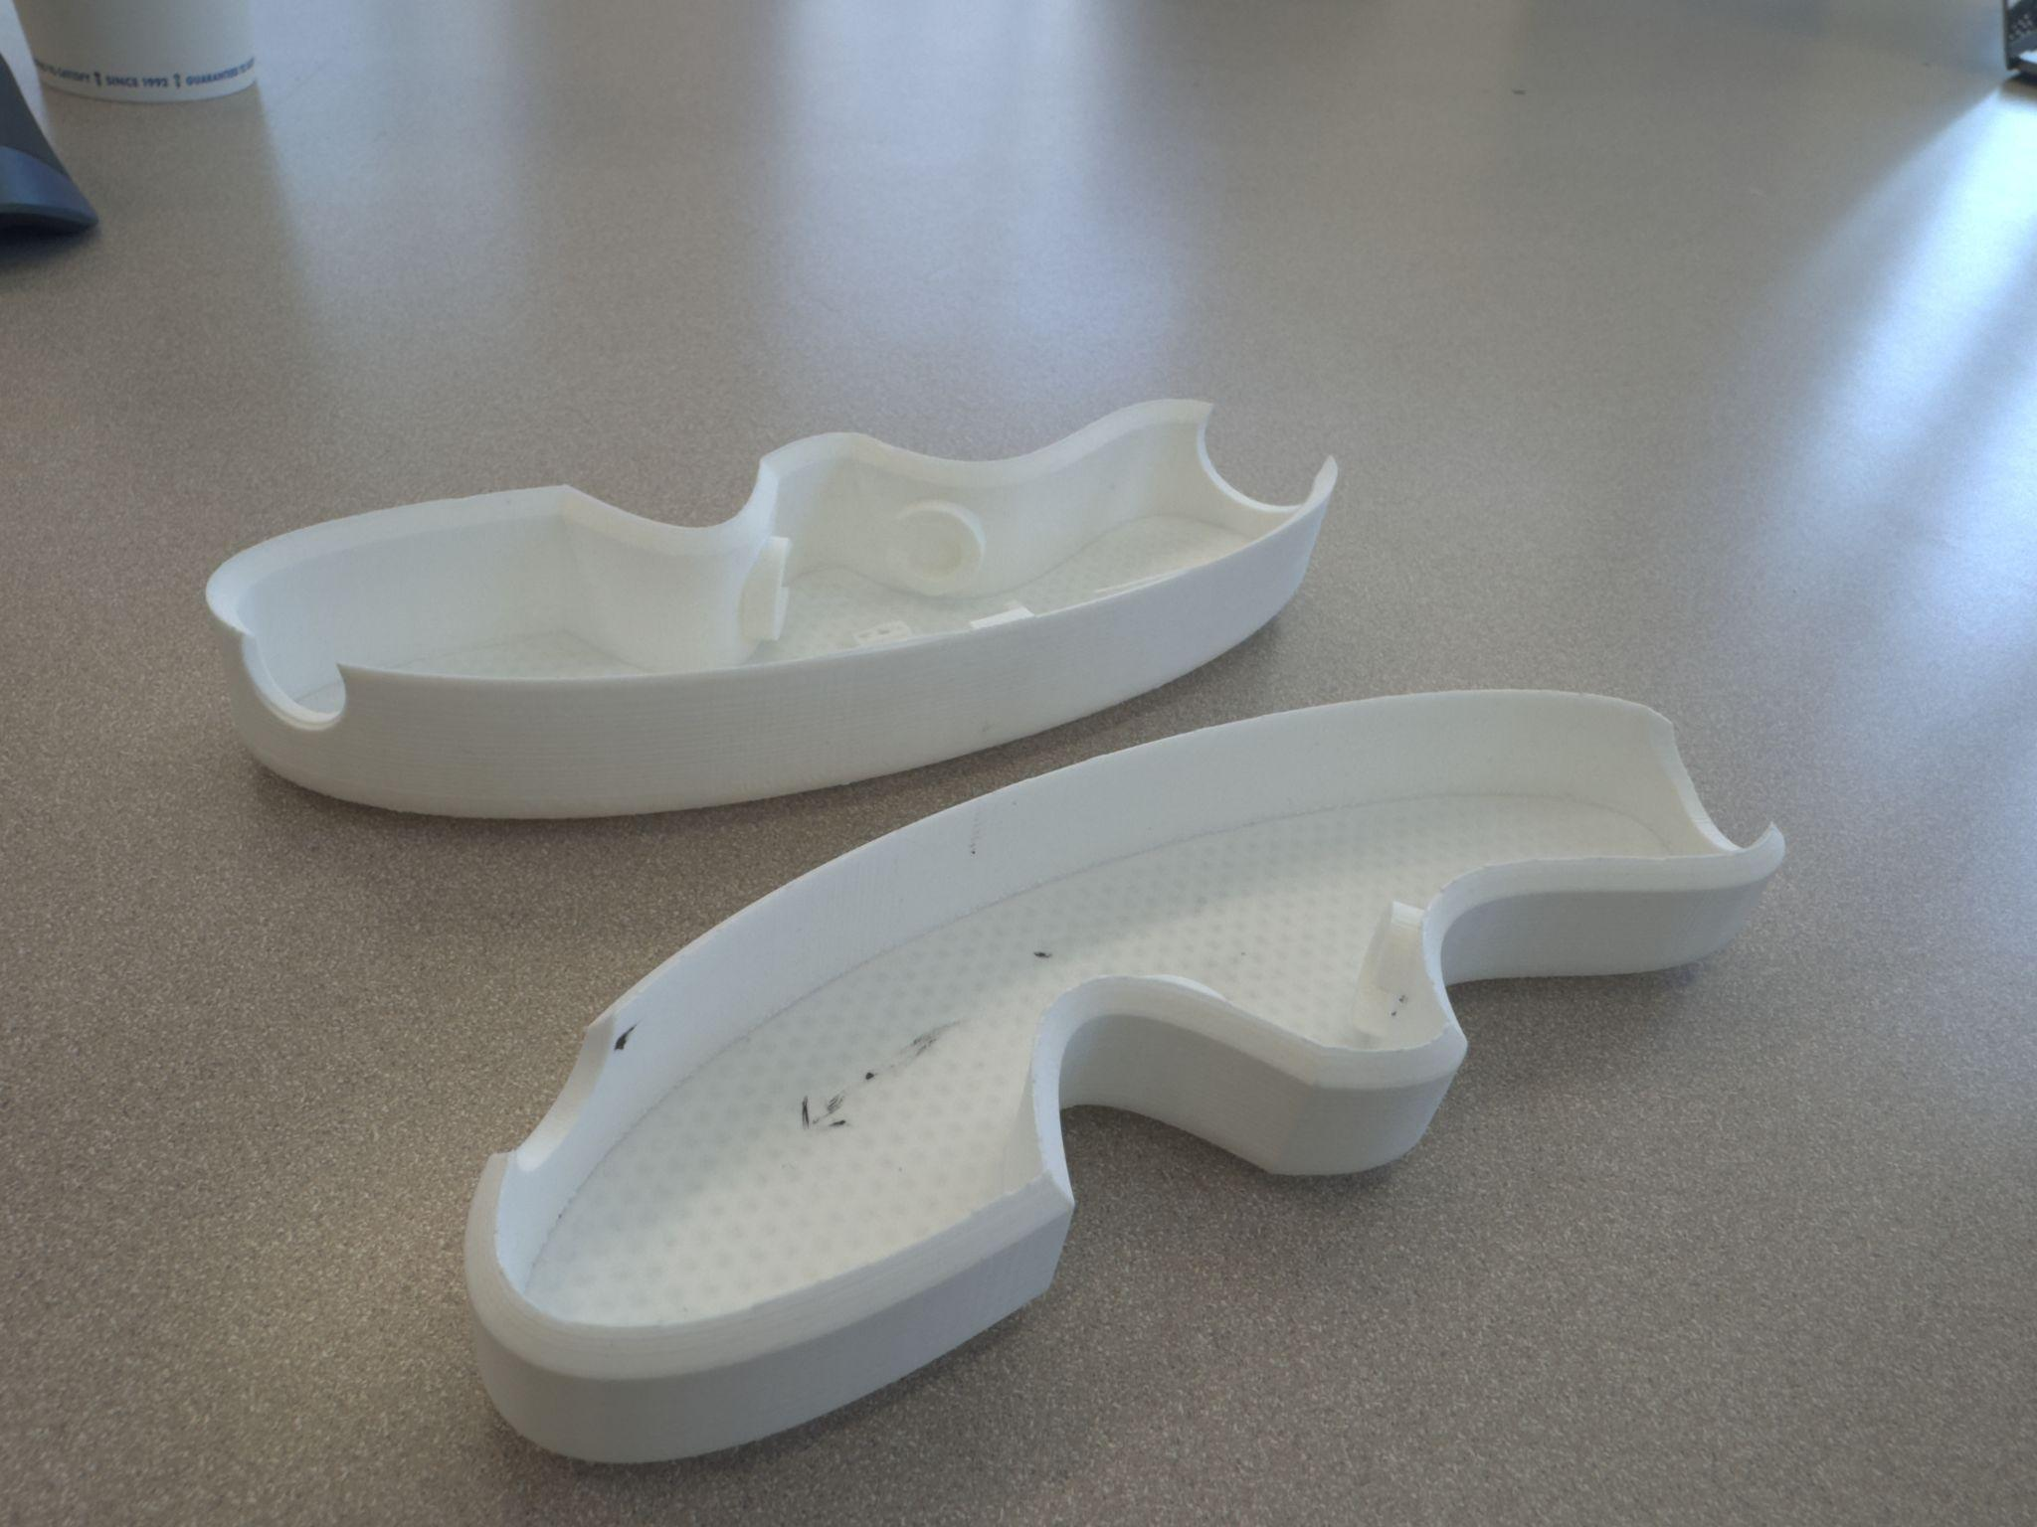

***Figure 11-12:*** *This is the first prototype we printed for the handle, as you can see from Figure 2-3, we have made quite a few changes based off our updated constraints and requirements*

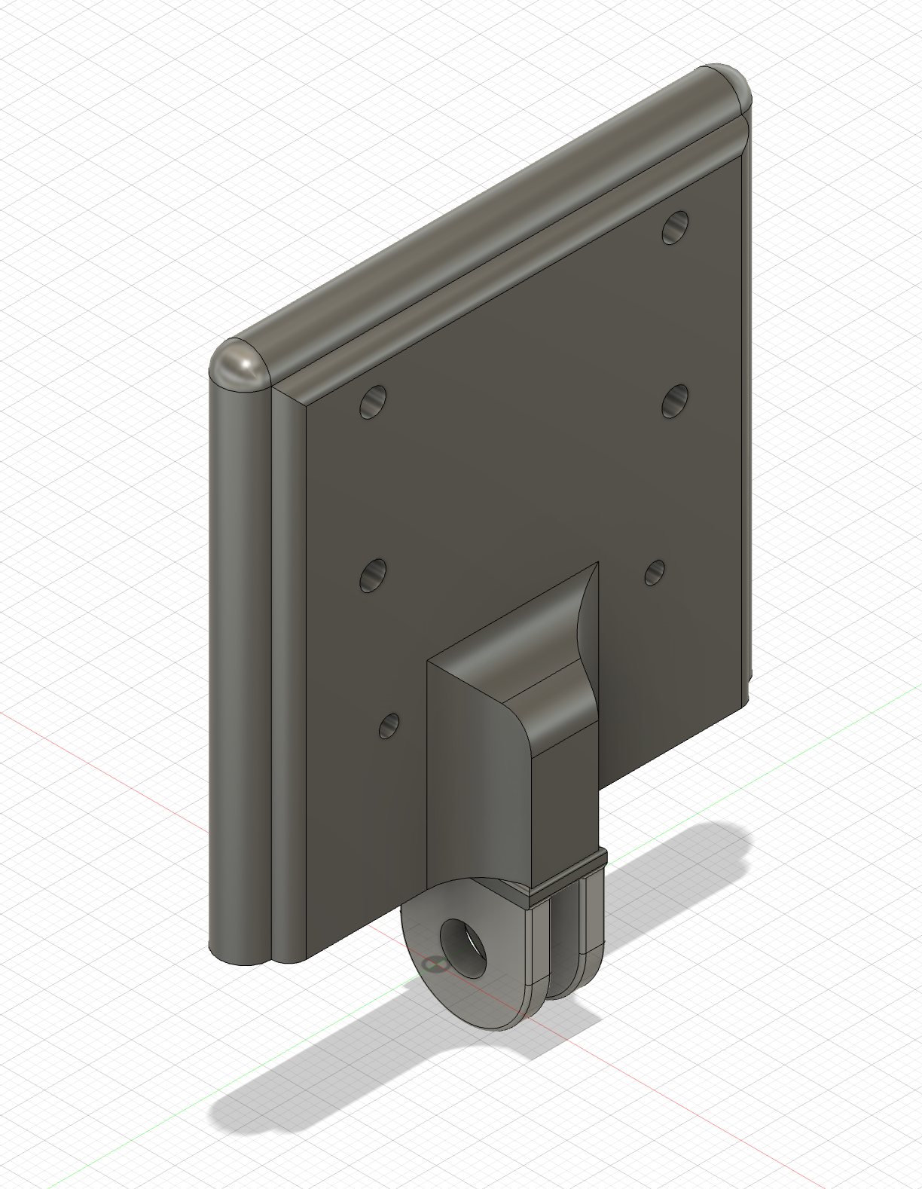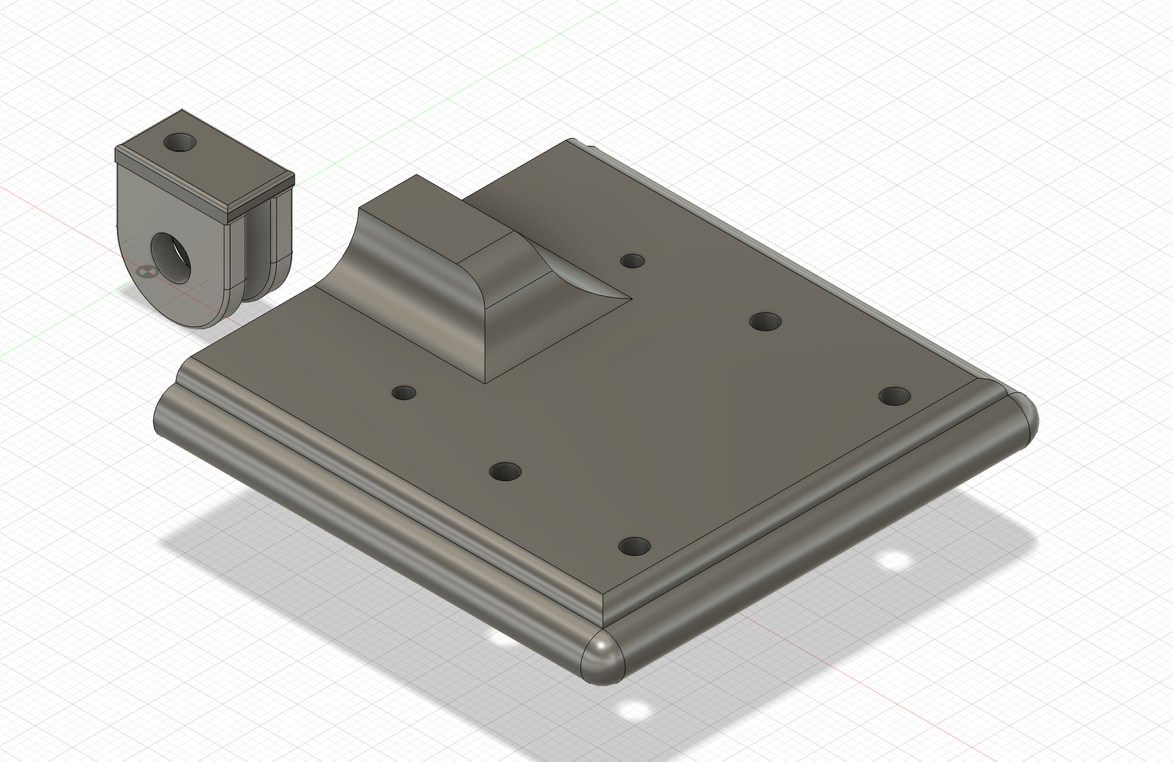

***Figure 13-14:*** *On the right side we have one of our first designs of the sensor mount. After printing and assembling this, we then designed our final design as you can see on the left. In this design, we have the whole body printed as a whole, removing any assembly issues which were brought into scope from assembling design as shown in the first prototype.*

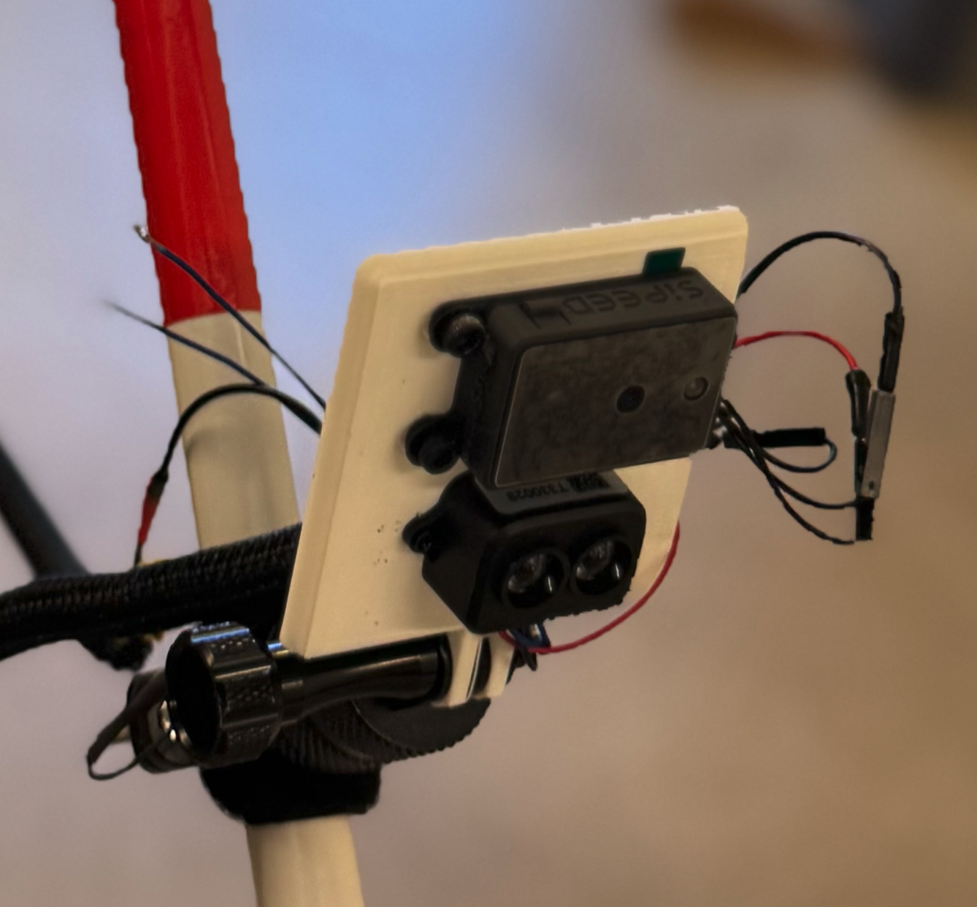

***Figure 15:*** *This is an image of the final prototype attached to our final profit with the sensors attached to the design. With this, we got a perfect fit for both the sensors as well as the attachment method to the stick.*

## Approach for design validation

The main objectives of GUIDE as stated in the sections above are to provide increased mobility to the visually impaired through obstacle detection and user alerts. These objectives are vital to the success of GUIDE and in the independence of those with visual impairments. Given our environment is a college campus we will be conducting all testing at Texas A&M University. We have allotted 3-4 weeks of integration testing as well as design validation.

The first objective is testing for mobility. GUIDE must be less than 2 pounds. To test this we will weigh the final design to ensure it is lightweight and every user regardless of physical ability and age is able to use GUIDE. In addition to weighing the cane we will walk with GUIDE around the university campus to ensure it does not cause strain to the user's arm for 20 minutes. GUIDE must be collapsable to ensure it is portable and users can store the cane easily. To test this we will ensure the final design can be collapsed and held in one hand, as the original design. Lastly, to ensure mobility, the team will power GUIDE for 3-4 hours to ensure it is fully functional for the duration of the battery’s life. At each half hour we will assess how the accuracy of each component has changed when yielding results.

The second objective of GUIDE is to detect obstacles using a LiDAR and depth camera. To ensure each component is functioning properly we will check each separately. We will test the depth camera by ensuring the videos and images output reflect the real-time environment being seen by the user. To do this we will test the camera attached to a computer with graphical capabilities and walk through the campus. This will be done in sunny, cloudy, rainy weather, and temperatures ranging from 90 degrees to 60 degrees. The LiDAR will be tested similarly but we will output the distances from obstacles using a computer terminal. To ensure these values are accurate we will physically measure the distance using a tape measure. These tests will be completed on the college campus in sunny, cloudy, rainy weather, and temperatures ranging from 90 degrees to 60 degrees. Once each component is tested separately we will integrate the two and ensure functionality does not become compromised. As GUIDE must detect obstacles 2m away from the user we will walk through the campus and run five tests. The first test will ensure if there is no obstacle 2m away the cane will not alert the user. The second test will place various obstacles within 2m of GUIDE. We will test using common obstacles on a college campus such as, curbs, medians, sidewalk barriers, pedestrians, bikes, scooters, squirrels, and cars. The third test will use the same subjects as test 2 but the distance between the obstacles will decrease to 1m. The fourth and fifth tests will use the same subjects as test 2 but the distances will decrease to 0.5m and 0m. As stated earlier, these tests will be completed in sunny, cloudy, rainy weather, and temperatures ranging from 90 degrees to 60 degrees. During these five tests we will print the distance and view the images/videos through a computer with graphical capabilities.

The last objective of GUIDE is to alert users when an obstacle is 2m, 1m, 0.5m, and 0m away and have less than a 0.5 second delay. The user must be alerted within 0.5 seconds there is an obstacle in front of them. To ensure this is true, we will collect timestamps and telemetry from the software of when the obstacle was detected and at what time the rumblers on the handle started vibrating. If the delay is not within 0.5 seconds we will look into optimizing the software to ensure latency meets the requirement. In addition to testing delay time, to ensure the user is alerted according to our requirements and objectives we will test the intensity of the rumbler at different distances. There will be a total of 4 tests where we will first test if the rumblers are triggered once an obstacle is detected 2m away from the user. The next test will be completed similarly but we will measure 1m away from the obstacle and ensure the rumblers increase the intensity of the vibrations. Next, we will measure 0.5m between GUIDE and the obstacle and make sure the rumblers are triggered with an even higher intensity. Lastly, once the obstacle is 0m away we will test the rumblers and have them set as the maximum vibrations, per the users sensitivity levels.

When completing the integration and testing portion of the schedule we would have validated our design can detect obstacles 2m away, respond for distances 2m, 1m, 0.5, 0m within 0.5 seconds and can have full functionality for 3-4 hours without causing physical strain due to weight or collapsibility.

# Implementation notes

## *Hardware Components*

While the hardware for this project is relatively simple, the correct implementation of all parts together is what made this project not only feasible but successful. In order to support the ability for multiple sensors to relay data to a single program, in a battery efficient and compact manner, component selection and implementation is crucial. In this section, we will go over each part, what it does and how it works, as well as the troubleshooting and best practices surrounding their use.

### *The UART Data Protocol*

UART (Universal Asynchronous Receiver-Transmitter) serves as the primary communication protocol between components in GUIDE.

**Key specifications:**

* Baud Rate: 115200 bps
* Data Bits: 8
* Stop Bits: 1
* Parity: None
* Flow Control: None
* Voltage Levels: 3.3V (logic high), 0V (logic low)

While not a piece of hardware on its own but rather a way of communication between devices, all components used in this project adhered and were compatible with UART protocol.

**Protocol Implementation Notes:**

* Start bit initiates each transmission by pulling line from high to low
* 8 data bits follow, LSB first
* No parity bit used to maximize data throughput
* One stop bit returns line to idle high state
* Frame format: [Start(1) | Data(8) | Stop(1)]
* Theoretical byte transmission time: ~87μs at 115200 baud (~11,494 bytes / 11.494 kB a second)

**Why UART?**

UART is simple, only needing 2 wires (TX and RX) to communicate data, not counting VCC/Ground. Not only is no clock signal needed, but it also sends data as ASCII characters for easy debugging and verification. There is no need for addressing, and it has a lower overhead compared to shared bus protocols. Within the context of our Capstone project, it worked great for device-to-device communication, had no problems with noise or clock skew, since all sensors/processors had their own internal clock.

**UART and Baud Rate**

* Operating at 115200 baud rate
* Minimal latency for real-time obstacle de
* Low error rate at this speed

**Compared alternatives**

* **I2C:** Requires a clock line, more complex, less data transmission due to overhead
* **SPI:** Needs more wires, more complex for multiple devices
* **CAN:** Overkill for simple device-to-device communication, higher cost
* **USB:** Requires drivers/USB ports, meant for larger devices and projects.

Overall, UART demonstrated its capabilities as a reliable and consistent serial communication protocol. Once implemented, it was the source of little to no troubleshooting problems. Besides correctly wiring up the devices, further integration details can be found in the software section.

### *SIPEED MaixSense A010 Depth Camera*

The SIPEED MaixSense A010 depth camera functions as one of our two sensors in GUIDE, providing rich 3D spatial information through advanced depth perception. This intelligent camera module was selected for its ability to detect and process complex environmental data, complementing the LiDAR's precise point measurements.

**Key specifications:**

* Resolution: 240x180 pixels
* Frame Rate: 30fps maximum
* Field of View: 68° wide-angle
* Power Input: 3.3-5.1V (strict requirement)
* Detection Range: 0.2m to 3m
* Current Consumption: 120mA typical
* Dimensions: 10mm x 2.7mm x 3mm

Integration of the A010 requires careful attention to power management and initialization sequencing. The sensor's 3.3-5.1V requirement necessitates voltage regulation through a buck converter or Raspberry Pi from our system's 9V source, with particular attention paid to clean power delivery and proper sequencing to prevent sensor damage.

**Power Requirements:**

* MUST use regulated 3.3-5.1V DC power supply
* Requires proper power sequencing:
* Begin UART communication

**UART Connection:**

VCC | 3V3 OUT

GND | GND

TX | GP5 (UART1 RX)

RX | GP4 (UART1 TX)

Data processing follows a structured approach where each pixel's depth value is calculated using the formula: distance = (pixel_value/5.1)^2. In testing, we achieved a consistent response time of 21.98ms operating independently.

**Response Times:**

* Initialization: 100ms
* Frame Processing: 21.98ms average
* Total Latency with LiDAR: 44.14ms

**Accuracy Considerations:**

* Best performance: 0.5m - 2m range
* Requires recalibration if mounting angle changes

**Common Issues and Solutions:**

* Black screen: Check power sequencing
* No data output: Verify UART configuration
* Poor accuracy: Clean lens, check lighting
* High latency: Reduce frame rate
* Communication errors: Check vcc/ground/RX/TX connections

### *TF-Luna LiDAR*

The TF-Luna LiDar serves as the primary distance error sensor in GUIDE, providing precise point measurements at high speed. This single-point LiDAR module was selected for its excellent balance of accuracy, speed, and cost-effectiveness in short-range detection applications.

**Key specifications:**

* Operating Voltage: 5V ±0.1V
* Current Draw: 50mA typical, 80mA peak
* Detection Range: 0.2m to ~6m
* Update Rate: 250Hz maximum
* Accuracy: ±2cm typical
* Field of View: 2° x 2°

**Implementation Notes:**

The TF-Luna's integration into GUIDE required careful consideration of power and communication requirements. The sensor demands a stable 5V power supply, which we achieve through a regulated buck converter from our 9V battery source. Proper grounding and shielding proved essential for reliable operation, particularly given the sensor's high-speed data output.

**UART Connection:**

VCC | Buck Converter OUT

GND | Buck Converter GND

TX | GP0 (UART1 RX)

RX | GP1 (UART1 TX)

Data transmission follows a straightforward protocol with fixed-length packets:

* Frame Header: 2 bytes (0x59, 0x59)
* Distance Data: 2 bytes (little-endian)
* Signal Strength: 2 bytes
* Temperature: 2 bytes
* Checksum: 1 byte

The LiDAR's response time averages 9.97ms when operating alone, making it our fastest sensor option. This incredible speed allows for real-time obstacle detection, crucial for user safety and navigation.

**Common Issues and Solutions:**

Issue: Fluctuating distance measurements

Solutions:

* Check power supply stability
* Verify mounting angle

Issue: Corrupted or missing data packets

Solutions:

* Verify UART configuration
* Check cable connections

Issue: Sensor resets or erratic behavior

Solutions:

* Check voltage regulation
* Monitor supply voltage

Issue: Misalignment or vibration problems

Solutions:

* Reinforce mounting
* Add dampening material

### *EBOOT DC-DC Buck Converter*

The EBOOT DC-DC buck converter serves as the primary voltage regulator in GUIDE, efficiently stepping down the 9V battery supply to a stable 5V for system components. This switching regulator was chosen for its high efficiency, small form factor, and excellent thermal performance. The converter's synchronous design minimizes power loss while providing clean output voltage even under varying load conditions.

Careful implementation of power distribution pathways and ground planes ensures optimal performance. The converter's placement within GUIDE's handle required special consideration for heat dissipation and EMI mitigation, leading to a design that balances electrical performance with mechanical constraints.

**Key specifications:**

* Input Voltage Range: 6.5V-24V
* Output: 5V fixed
* Maximum Current: 3A
* Efficiency: ~92%
* Switching Frequency: 150kHz
* Dimensions: 22mm x 17mm x 4mm
* Operating Temperature: -40°C to 85°C
* Ripple Voltage: <50mV

**Implementation Notes:**

The converter's integration demanded careful attention to PCB layout and component placement. Ground planes were strategically split to isolate switching noise from sensitive analog circuits. Thermal management became a key consideration given the confined space within the handle. A systematic testing protocol validated the converter's performance across various load conditions. Load step response testing confirmed stable operation during any voltage or current demand from the sensors. No thermal issues occurred.

**Common Issues and Solutions:**

No implementation issues happened during the build process. If the amount of power drawn from the sensors was significantly higher, or the battery was a lower voltage/power/mAH, then a more complex system would have to have been implemented.

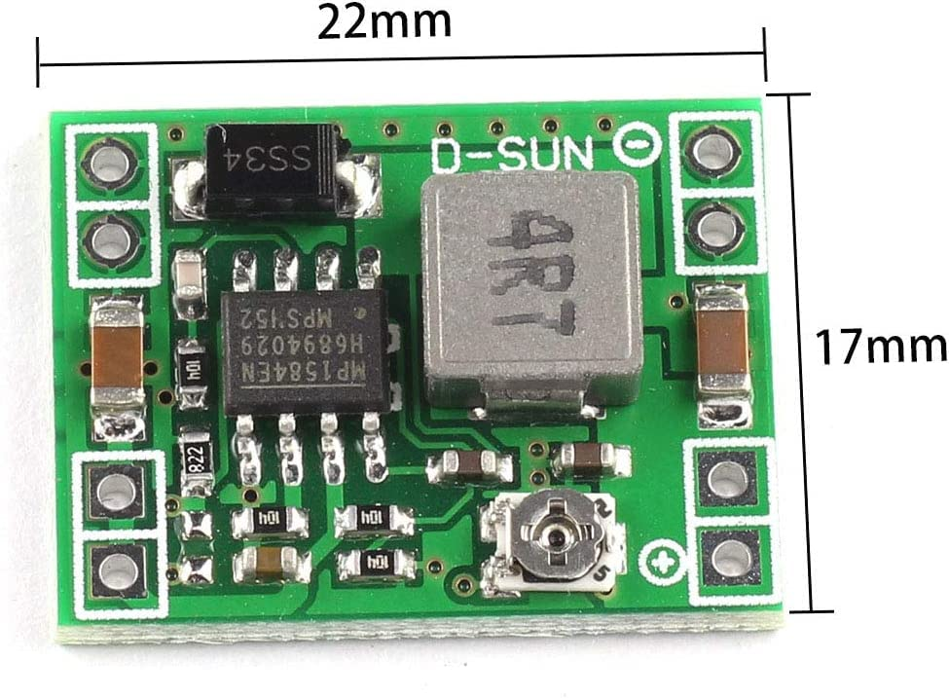

***Figure 16:*** *Buck Converter dimensions and image.*

### *BOANV 1300mAH 9V Rechargeable Battery*

The BOANV rechargeable battery forms the core power system of GUIDE, delivering consistent and reliable power to all system components. As a Li-ion based solution, it offers the optimal balance between capacity, size, and rechargeability. The battery's integrated Protected Circuit Module (PCM) provides crucial safety features, monitoring voltage, current, and temperature to prevent dangerous operating conditions. Our implementation prioritizes user safety while maintaining ease of access for replacement. Special consideration was given to the mounting solution, which includes a secure latching mechanism.

**Key specifications:**

* Capacity: 1300mAH
* Nominal Voltage: 9V
* Chemistry: Lithium-Ion battery
* Charging time: 45 minutes to an hour
* Weight: ~120g

**Implementation Notes:**

Battery integration requires careful attention to protection circuits and charging management. Our chosen battery includes charging requirements such as charging voltage 9.6V +-0.05V, and overcharge protection (battery trips if hit with a voltage/current surpassing its operating conditions)

**Real-world testing revealed the following performance metrics:**

Battery Duration:

* 1.5-2 hours continuous/heavy use
* 3-3.5 hours intermittent use
* No limit on standby time

Voltage Stability:

* 9.6V at full charge
* 9.0V nominal operation
* <=6.0V cutoff threshold

**Common Issues and Solutions:**

Reduced Runtime

* Cause: Battery aging or temperature extremes
* Solution:
  + Replace battery after several hundred charge cycles
  + Avoid complete discharge

Charging Problems

* Cause: Poor connection or charger issues
* Solution:
  + Clean charging contacts
  + Verify charger output voltage
  + Check for bent pins
  + Use only supplied charger

Rapid Discharge

* Cause: High current draw or component failure
* Solution:
  + Check for shorts in circuitry
  + Verify sensor operation
  + Monitor system current draw
  + Inspect PCM functionality

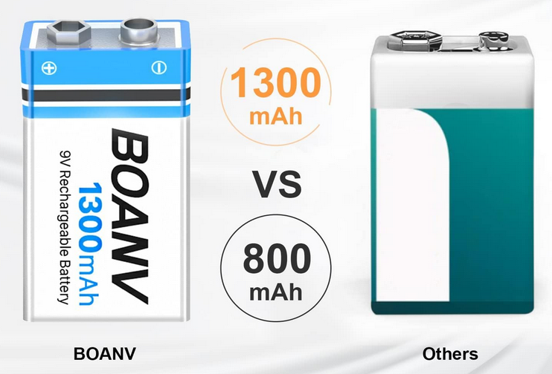

***Figure 17:*** *9V rechargeable battery image.*

### *12V DC Toggle Switch*

The power switch serves as the primary user interface for controlling GUIDE's power state. We selected a robust toggle switch rated for 12V DC operation, providing tactile feedback and reliable switching performance. The switch's waterproof design and metal construction ensure durability in various environmental conditions, while its illuminated LED indicator provides clear visual feedback of system power status.

Integration into GUIDE's handle required careful consideration of ergonomics and accessibility. The switch location allows easy activation while maintaining protection against accidental toggling. A custom mounting solution includes water-resistant gaskets and secure retention mechanisms.

**Key Specifications:**

* Voltage Rating: 12V DC
* Current Rating: 20A
* Contact Resistance: ≤50mΩ
* Insulation Resistance: ≥100MΩ
* Mechanical Life: 50,000 cycles
* Operating Temperature: -25°C to 85°C
* Dimensions: 16mm diameter
* IP65 Waterproof Rating
* Built-in LED Indicator

**Implementation Notes:**

Power switching implementation focuses on reliability and safety. The switch controls the main power line through a clean break configuration, ensuring complete system shutdown when toggled off. Special attention was paid to the mounting orientation and accessibility for users with limited vision.

**Common Issues and Solutions:**

The most frequent challenge encountered with the toggle switch involves contact degradation, which manifests as intermittent power delivery to the system. When this occurs, users might notice flickering of the LED indicator or inconsistent system operation. Additionally, soldering the joints securely prevented taking the switch out of the device from breaking the connection.

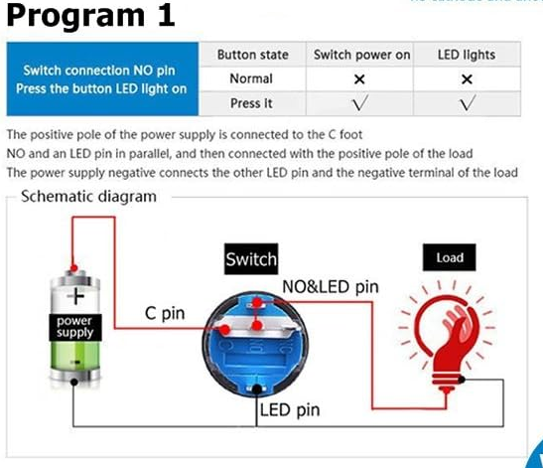

***Figure 18:*** *Power button image and wire diagram.*

### *VAKTOK Mini Vibration Motor*

**Key specifications:**

* Operating Voltage: 3-5V DC
* Current Draw: 100mA maximum
* Speed: 10000 RPM nominal
* Vibration Amplitude: 0.8G
* Dimensions: 10mm x 2.7mm
* Operating Temperature: -20°C to 60°C
* Weight: ~<= 1g

**Implementation Notes:**

The vibration motors serve as GUIDE's primary feedback mechanism, translating sensor data into tactile alerts for the user. Implementation required careful consideration of mounting techniques to maximize vibration transfer while minimizing unwanted resonance through the handle structure.

**Common Issues and Solutions:**

Motor reliability and flexibility presented initial challenges during development, primarily related to consistent vibration intensity and long-term durability. Getting the vibration to feel consistent during a remount or with the full handle attached was a challenge as well. Noise generation, which was a concern of ours due to the nature of the users, was negligible.

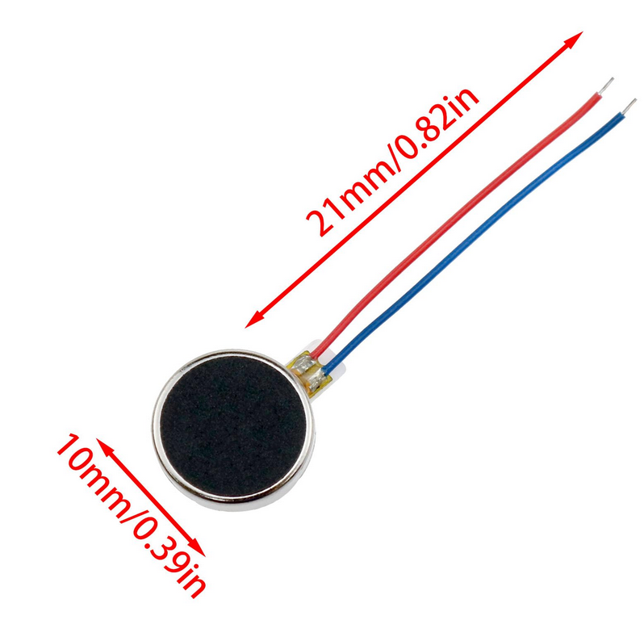

***Figure 19:*** *Vibration motors image and dimensions.*

### *Raspberry Pi Pico 2*

**Key specifications:**

* Processor: RP2040 dual-core Arm Cortex M0+
* Clock Speed: 133MHz
* RAM: 264 KB SRAM
* Flash Memory: 2MB
* GPIO: 26 programmable pins
* ADC: 12-bit, 4 channels
* Operating Voltage: 1.8V to 5.5V
* Dual UART Controllers
* Temperature Range: -20°C to 85°C
* Dimensions: 21mm x 51mm
* Power Consumption: ~100mA typical
* USB 1.1 Controller and PHY

**Implementation Notes:**

The Raspberry Pi Pico 2 serves as GUIDE's central processing unit, orchestrating sensor data collection and feedback generation. Integration required careful consideration of power management, with particular attention to brownout prevention during high-current events. Our implementation utilizes the Pico's internal voltage regulator while maintaining stable power delivery through strategic bypass capacitor placement and dedicated power planes in the PCB design.

The microcontroller's pin allocation underwent several iterations to optimize signal integrity and minimize cross-talk. UART communications for both the LiDAR and depth camera operate on separate controllers to prevent data collisions, while PWM outputs for vibration motor control utilize pins with minimal adjacent noise-sensitive signals.

**Common Issues and Solutions:**

Power sequencing initially caused inconsistent startup behavior, particularly with the depth camera. We fixed this by adding and adjusting wait() functions in order for the depth camera to fully power on and become responsive before the raspberry pi pico 2 started issuing AT commands. Memory management was also a problem initially, with the Depth Camera loading in and processing a ridiculous amount of data, and storing in lists that eventually resulted in running out of memory. It is important to note that many of the things you take for granted with laptop or desktop computing are not available in an embedded work environment, with cpu and ram resources becoming a tradeoff of space, weight, and power consumption.

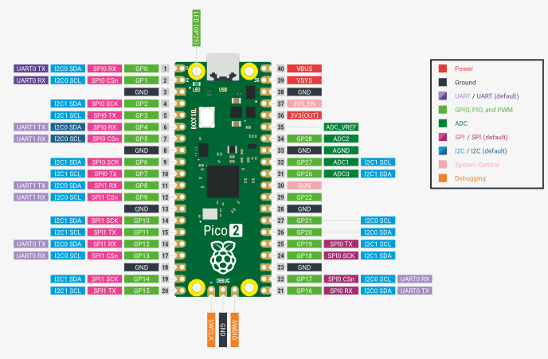

***Figure 20:*** *Raspberry Pi Pico 2 pinout diagram.*

3D Modeling

|  | Amount | Amount per Unit | Cost per Unit | Total Amount ($) |
| --- | --- | --- | --- | --- |
| PLA Printer Filament | 63g | 63 | $0.055 (per g) | $3.50 |

***Table 5:*** *3D printing prices for GUIDE handle.*



***Figure 21:*** CAD for left side of handle body. This body includes pins for Raspberry Pi Pico Mounting, cutouts for power button and stick connection, and there are also cutouts for 2 vibrating motors.



***Figure 22:*** *CAD for right side of handle body. This body includes a mount for the Buck converter which allows us to drop the voltage from the 9v battery to 5v. It also includes a battery mount, two vibrating motor mounts, and cutouts for the walking cane connection and a power button cutout.*

**

***Figure 23-24:*** *This is the first prototype we printed for the handle, as you can see from Figure 23-24, we have made quite a few changes based off our updated constraints and requirements*

### *Programming a Raspberry Pi Pico 2 With Thonny*

While GUIDE was still in prototype form, we used Thonny IDE. This IDE was made for MicroPython, as well as loading and booting programs that can be displayed and monitored for testing purposes.

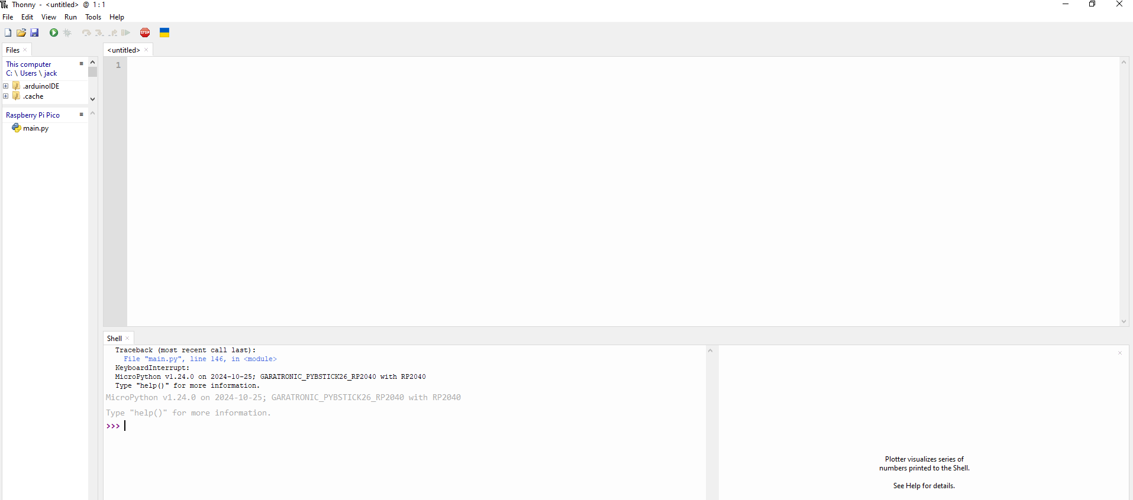

***Figure 25:*** *A view of Thonny IDE.*

Setting up the Environment was as easy as configuring the python interpreter to MicroPython, and ensuring the correct bootloader/firmware was present on the Pi.

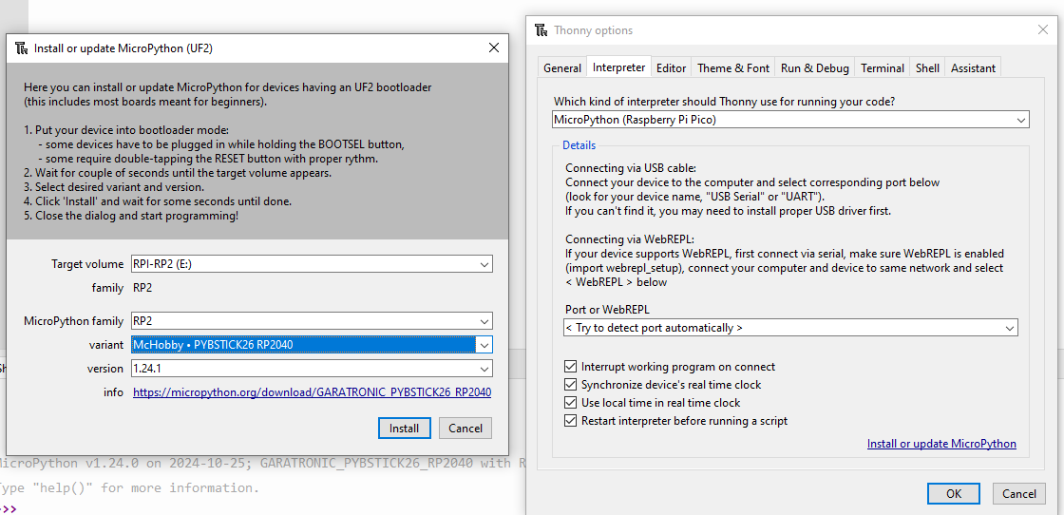

***Figure 26:*** *Configuration settings required to boot and load programs on the Raspberry Pi Pico 2*

Once configuration is complete, all python code with libraries compatible with MicroPython can be used and tested on the connected device.

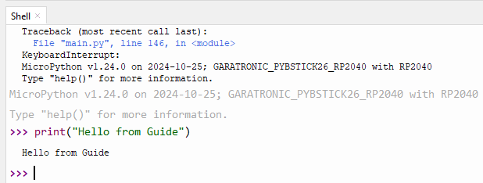

***Figure 27:*** *Quick test demonstrating python capability of the Pi, as well as the debug capability of Thonny for this project*

Once satisfied with the code, simply save it and power the device without connecting to a computer or in bootloader mode. The Raspberry Pi Pico will now run the code, regardless of the way it is powered or hooked up to a computer.

### *Putting it all together*

The integration of GUIDE's components requires a methodical, systematic approach to ensure proper functionality and reliability. The assembly process begins with the preparation of the 3D-printed handle, which serves as the central housing unit for most electronic components. Before installation, all components undergo individual testing to verify proper operation and compatibility with the system specifications.

The power distribution system forms the foundation of the assembly. The 9V battery holder is mounted in its designated compartment, followed by the installation of the buck converter in close proximity to minimize power trace lengths. The power switch is mounted through its pre-designed opening, with careful attention to waterproofing using the provided gaskets and ensuring proper compression during installation.

The Raspberry Pi Pico 2 mounts to a designated rectangle within the handle, positioned to optimize cable routing while maintaining accessibility for potential future maintenance. All power and ground connections are made first, followed by systematic connection of sensor and control signals. Each connection undergoes continuity testing before proceeding to the next step.

Sensor integration requires particular attention to alignment and positioning. The LiDAR and depth camera mount to their custom bracket, with careful consideration given to maintaining proper angular alignment. Cable routing from the sensors to the handle utilizes strain relief points and protective sheathing to prevent wear from repeated movement.

### *General Safety, Good Practices, etc.*

Electrical Safety

Working with GUIDE's electrical systems requires strict adherence to safety protocols. All power connections should be verified with a multimeter before applying power to prevent potential damage to sensitive components. When handling the circuit board or electronic components, proper ESD protection must be employed, including the use of grounded work surfaces and wrist straps.

Assembly

Component installation follows a specific sequence to prevent damage and ensure proper fit. Cable routing pathways are designed to prevent interference between signal lines and power distribution, with particular attention to keeping sensor cables away from potential noise sources.

Maintenance

Regular maintenance procedures have been established to ensure long-term reliability. Monthly inspections should include checking all mounting hardware for proper tightness, verifying sensor alignment, and inspecting cable conditions for any signs of wear. Battery voltage should be monitored regularly, with replacement recommended when runtime begins to decrease notably.

Quality Assurance

Each assembled unit undergoes a comprehensive testing protocol including:

* Full power system verification
* Sensor calibration and alignment checks
* Communication system verification
* Tactile feedback response testing
* Environmental exposure testing

This systematic approach to assembly and quality control ensures that each GUIDE unit meets our stringent performance and reliability standards while maintaining user safety as the paramount concern.

*Software Components*

The software initializes UART communication with both the LiDAR sensor and the depth camera, reads data from them, processes the readings, and controls the LED and buzzers based on specific distance thresholds.

### *Libraries and Imports*

from machine import UART, Pin

import utime

import struct

* **machine.UART**: For UART communication.
* **machine.Pin**: For GPIO pin control.
* **utime**: For time-related functions.
* **struct**: For binary data unpacking.

### *GPIO Initialization*

led = machine.Pin(25, machine.Pin.OUT)

buzzer_one = machine.Pin(10, machine.Pin.OUT)

buzzer_two = machine.Pin(14, machine.Pin.OUT)

* **led**: Controls the onboard LED.
* **buzzer_one**: Controls the first buzzer.
* **buzzer_two**: Controls the second buzzer.

### *UART Initialization*

uart0 = UART(0, baudrate=115200, tx=Pin(0), rx=Pin(1)) # LiDAR

uart1 = UART(1, baudrate=115200, tx=Pin(4), rx=Pin(5)) # Depth Camera

* **uart0**: Communicates with the LiDAR sensor.
* **uart1**: Communicates with the depth camera.

## *Functions and Their Roles*

### 1. send_at_command(command)

#### **Purpose**

Sends configuration commands to the depth camera over UART and reads the response.

#### **Parameters**

* **command (str)**: The AT command to send to the depth camera.

#### **Operation**

* Writes the command followed by a carriage return (\r) to uart1.
* Waits for 100 milliseconds.
* Reads any available response from the depth camera.
* Prints the command and response for debugging.

#### **Return Value**

* **response (bytes)**: The response from the depth camera.

#### **Code Snippet**

def send_at_command(command):

uart1.write(command + '\r')

utime.sleep_ms(100)

response = b''

if uart1.any():

response += uart1.read()

print(f"Command: {command}, Response: {response}")

return response

### 2. initialize_camera()

#### **Purpose**

Initializes the depth camera with specific configuration settings.

#### **Operation**

* Sends AT commands to:
  + Enable UART display (AT+DISP=5).
  + Set the unit to a specific value (AT+UNIT=9).
  + Set the frame rate (AT+FPS=15).
* Introduces delays between commands to ensure proper communication.

#### **Code Snippet**

def initialize_camera():

utime.sleep_ms(100)

send_at_command("AT+DISP=5") # Enable UART display

utime.sleep_ms(100)

send_at_command("AT+UNIT=9")

utime.sleep_ms(100)

send_at_command("AT+FPS=15")

### 3. read_lidar()

#### **Purpose**

Reads distance data from the LiDAR sensor.

#### **Operation**

* Checks if data is available on uart0.
* Reads the data and verifies if it starts with the header bytes ('YY').
* Unpacks the distance value from the data.
* Updates last_frame_time.
* Returns the distance.

#### **Error Handling**

* Catches exceptions and prints errors without interrupting the main loop.

#### **Return Value**

* **distance (int)**: The distance measured by the LiDAR sensor.
* **None**: If no valid data is available.

#### **Code Snippet**

def read_lidar():

global last_frame_time

current_time = utime.ticks_ms()

try:

if uart0.any():

data = uart0.read()

if len(data) >= 7 and data.startswith(b'YY'):

distance = struct.unpack('<H', data[2:4])[0]

last_frame_time = current_time

return distance

else:

return None

except Exception as e:

print(f"Error: {e}")

return None

return None

### 4. get_distance_from_packet(data_bytes)

#### **Purpose**

Extracts distance measurements from the data packet received from the depth camera.

#### **Operation**

* Searches for the packet header (0x00, 0xFF).
* Verifies packet length to ensure it has sufficient data.
* Processes pixel data starting from the frame start position.
* Calculates distance values for each pixel.
* Computes the average distance from all pixel values.

#### **Return Value**

* **avg_distance (float)**: The average distance calculated from the packet.
* **None**: If no valid packet is found or an error occurs.

#### **Code Snippet**

def get_distance_from_packet(data_bytes):

try:

if len(data_bytes) < 32:

return None

for i in range(len(data_bytes) - 1):

if data_bytes[i] == 0x00 and data_bytes[i+1] == 0xFF:

packet = data_bytes[i:]

if len(packet) < 22:

return None

frame_start = i + 20

pixel_values = []

for idx in range(frame_start, len(data_bytes), 3):

p = data_bytes[idx]

distance = int((p / 5.1) ** 2)

pixel_values.append(distance)

if pixel_values:

avg_distance = sum(pixel_values) / len(pixel_values)

print(f"Packet found at {i}, Average Distance: {avg_distance}")

return avg_distance

else:

return None

return None

except Exception as e:

print(f"Error in get_distance_from_packet: {e}")

return None

### 5. read_camera_non_blocking()

#### **Purpose**

Performs a non-blocking read from the depth camera to prevent the main loop from stalling.

#### **Operation**

* Checks if data is available on uart1.
* Reads the available data and appends it to camera_data_buffer.
* Checks if a complete packet has been received (minimum 32 bytes).
* Attempts to extract distance using get_distance_from_packet().
* Resets the buffer and flags if a valid distance is obtained.
* Maintains the buffer size to prevent memory overflow.

#### **Return Value**

* **distance (float)**: The average distance from the depth camera.
* **None**: If no valid data is available yet.

#### **Code Snippet**

def read_camera_non_blocking():

global camera_data_buffer, camera_reading_in_progress

try:

if uart1.any():

data = uart1.read(uart1.any())

if data is not None:

camera_data_buffer.extend(data)

if len(camera_data_buffer) >= 32:

distance = get_distance_from_packet(camera_data_buffer)

if distance is not None:

camera_data_buffer = bytearray()

camera_reading_in_progress = False

return distance

else:

camera_data_buffer = camera_data_buffer[-64:]

except Exception as e:

print(f"Camera Error: {e}")

camera_data_buffer = bytearray()

camera_reading_in_progress = False

return None

### *Initialization Steps*

**Print Initialization Message**  
print("Initializing camera...")

**Send Basic AT Command**  
send_at_command("AT")

**Initialize Camera Settings**  
initialize_camera()

print("Camera initialized.")

### *Global Variables*

**Timing Variables**  
last_frame_time = None

last_frame_time_camera = None

**Camera Reading Flags**  
camera_data_buffer = bytearray()

camera_reading_in_progress = False

**Main Loop Variables**  
n = 1 # Multiplier for LiDAR scans

start_time = utime.ticks_ms()

lidar_scan_count = 0

last_depth_camera_time = start_time

lidar_readings = []

### *Main Loop Structure*

while True:

# Read LiDAR data

# Check if it's time to initiate depth camera reading

# Read depth camera data if in progress

# Process readings and control outputs

# Error handling

### *LiDAR Data Reading*

* Reads data using read_lidar().
* Increments lidar_scan_count for each successful reading.
* Stores readings in lidar_readings list.

### *Depth Camera Reading Initiation*

* Initiates reading if:
  + lidar_scan_count reaches n * 100.
  + 10 seconds have passed since the last depth camera reading.
* Sets camera_reading_in_progress to True.
* Resets lidar_scan_count and updates last_depth_camera_time.

### *Reading Depth Camera Data*

* If camera_reading_in_progress is True, calls read_camera_non_blocking().
* If a valid distance is obtained, proceeds to processing.

### *Processing Readings*

* **Average Distance Calculation**
  + Combines lidar_readings and the depth camera reading.
  + Calculates the average distance.
* **Output Control Logic**
  + **First Threshold**: Distance between 100 and 200 cm (LiDAR) or 1000 and 2000 cm (Depth Camera)
    - **Action**: Turn on LED and buzzer_one.
  + **Second Threshold**: Distance between 50 and 100 cm (LiDAR) or 500 and 1000 cm (Depth Camera)
    - **Action**: Turn on LED and buzzer_two.
  + **Third Threshold**: Distance less than 50 cm (LiDAR) or less than 500 cm (Depth Camera)
    - **Action**: Turn on LED, buzzer_one, and buzzer_two.
  + **Else**: Turn off all outputs.
* **Resetting for Next Cycle**
  + Clears lidar_readings.
  + Resets camera_reading_in_progress.

### *Error Handling*

* Wraps the main loop content in a try-except block to catch and print any exceptions.

### *LiDAR Data Processing*

* The LiDAR sensor sends data packets starting with 'YY'.
* The distance is extracted from the next two bytes after the header.
* Uses struct.unpack('<H', data[2:4])[0] to unpack a little-endian unsigned short.

### *Depth Camera Data Processing*

* Searches for a packet header (0x00, 0xFF) in the data buffer.
* Verifies packet length (minimum 32 bytes).
* Skips over header, length, and other bytes to reach pixel data.
* Processes pixel data by interpreting each pixel's value:
  + Converts pixel value p to distance using the formula distance = int((p / 5.1) ** 2).
* Calculates the average distance from all pixel values.

### *Output Control Logic*

* **Thresholds are based on sensor capabilities**:
  + LiDAR distances are in centimeters.
  + Depth camera distances might be scaled differently; adjust thresholds accordingly.
* **Activation of Outputs**:
  + LED and buzzers are activated based on the proximity of an object.
  + The closer the object, the more outputs are activated.

### *Adjusting Thresholds*

* Threshold values are hardcoded but can be adjusted according to application needs.
* Modify the conditions in the main loop where outputs are controlled.

### *Changing UART Settings*

If different baud rates or UART pins are required, update the UART initialization:  
uart0 = UART(0, baudrate=desired_baudrate, tx=Pin(tx_pin), rx=Pin(rx_pin))

### *Adding Sensors*

* To add more sensors, initialize additional UART interfaces or GPIO pins.
* Write corresponding read functions similar to read_lidar() or read_camera_non_blocking().

### *Error Handling Enhancements*

* Implement more robust error handling and logging.
* Consider adding retries or fallbacks if sensor readings fail.

### *Power Management*

* Introduce sleep modes or reduce polling frequency to save power in battery-operated systems.

### *UART Buffer Overflows*

* Ensure that the UART buffers do not overflow by reading data promptly.
* The code maintains the camera_data_buffer size to prevent memory issues.

### *Timing Conflicts*

* Non-blocking reads prevent the main loop from stalling.
* Be cautious with timing, especially if adding delays or additional processing.

### *Sensor Compatibility*

* Verify that the sensors are compatible with the microcontroller's voltage levels.
* Adjust the code if sensors have different communication protocols.

### *Scaling and Calibration*

* Distance calculations may need calibration based on the specific sensors used.
* Test and adjust the formulas in get_distance_from_packet() as necessary.

# Experimental results

GUIDE was tested around the Texas A&M campus both indoors and outdoors using the validation procedures outlined in our CDR. The main requirements were ensuring GUIDE was within 1.5lbs - 2lbs, the response latency was less than 0.5 seconds, and GUIDE was able to detect obstacles starting at 2m distance and change the haptic feedback at 1m and 0.5m.

Test 1: Obstacle Detection

The first test was ensuring GUIDE could detect obstacles at 2m. To complete this, a member of the team stood with GUIDE in front of them. We calibrated the sensor mount according to the member's height. Using a tape measure, we measured 2m from the user into the environment. Then, we had another member of our team walk in front of GUIDE to ensure the user was receiving haptic feedback.

The goal of this test was to ensure the main function of GUIDE was functioning properly. Once this test was concluded we could then move onto testing in different environments.

Test 2: Weight

The second test we conducted for GUIDE was weighing the final prototype. Along with the walking stick which is a little over 1 lb we added two 3D printed parts and many electronics to the walking stick. To ensure we remained within the limits of our requirements and ensure there is no strain for the user we used a scale to weight GUIDE.

The goal of this test was to ensure there was no undue strain on the user when using GUIDE. When using a walking stick for the visually impaired the user must hold the cane and move it from side to side. The side to side motion can cause strain to the user's arm as time passes.

Test 3: Latency

The third test was ensuring GUIDE could detect obstacles and alert the user through the haptic feedback in the handle. To test this we had a member of the team hold GUIDE and similar to the first test, another team member walked towards the walking stick and stopped when the user received haptic feedback. Additionally, the user walked with the stick around the EABA and once they received vibrations they moved in another direction to make sure alerts were received before the user bumped into the obstacle.

The goal of this test was to ensure the main goal of GUIDE, innovating the current walking stick was complete. The traditional walking stick waits to alert the user through touch when the walking stick hits an obstacle. Ensuring GUIDE can alert the user before the walking stick hits an obstacle is a key component.

Test 4: Classroom Obstacle Detection

The fourth test was ensuring GUIDE operated fully in the intended environment of a University classroom. The team moved into the EABA hallway where there are tables, chairs, cubicles, and walls. A member of the team held GUIDE as the intended design required. The rest of the team scattered chairs around the hallway and charted a path for the member holding GUIDE. The user began at one end of the hallway and walked towards the other end. As the user encountered chairs, walls, and tables the user verbally stated when they felt a vibration from the handle.

The goal of this test is to ensure stationary objects are able to be detected by GUIDE. Common objects found in classrooms were scattered throughout to simulate a common environment the user would encounter in a classroom environment. This test was designed to test every aspect, the vibrations, the object detection, and the strain on the user's arm.

Test 5: Classroom Human Detection

The fifth test was ensuring GUIDE operated fully in the intended environment of a University classroom and the social environment of a University. The team conducted this test in the EABA hallway where members of the team walked through the hallway, and walked towards the user holding GUIDE and then pivoting their direction. The user holding GUIDE stood on one end of the EABA hallway and began walking towards the opposite end. While walking, some members of the team crossed perpendicular to GUIDE and the user. Another team member walked towards GUIDE and once close enough pivoted their direction.

The goal of this test was to ensure moving objects were detectable by GUIDE. It is common for students, teachers, faculty, and staff to be walking around inside and outside of campus. Texas A&M houses over 60,000 students alone, therefore this test was crucial for those who have visual impairment.

Test 6: Outdoor Obstacle Detection

The sixth test was ensuring GUIDE was fully operational in outdoor settings and detecting different kinds of obstacles. Common obstacles outside of the classroom include benches, curbs, people, signs, buildings, along with many other obstacles. To complete this test, a member of the team held GUIDE outside of the EABA building and walked towards the street. To ensure GUIDE could detect lower obstacles such as curbs the user walked towards the other side of the road and detected the curb before the walking stick touched the curb. The user then walked towards a bench to detect an outdoor obstacle. During this test, a student walking by was detected by GUIDE.

The goal of this test was to ensure outdoor environments function similarly to indoor environments. When being outdoors there are other factors that you can’t control such as lighting, and the ground. The sensors on GUIDE operate using depth, theoretically lighting should not affect it but our team wanted to test to make sure this was the case.

Test 7: Busy Area Obstacle and Human Detection

The seventh test was conducted to ensure GUIDE operated in busy environments on the Texas A&M campus. Texas A&M is home to over 60,000 students, there are areas where students convene in masses. Near the EABA there is a common area which includes study rooms, computer labs, 4 dorm rooms, and a cafeteria. This area is frequented by hundreds of students every day. To test in this area we had a member of our team hold GUIDE. The test started outside of the Commons automatic doors where the user moved GUIDE back and forth. When inside the commons, the user walked through the common area, encountering furniture, signs, and students.

The goal of this test was to ensure GUIDE provided the right amount of feedback in a congested environment on the Texas A&M campus. This test combined both indoor and outdoor scenarios and object detection for both stationary and moving objects. It was a real test of how GUIDE would perform on an actual college campus.

Results

Test 1: Obstacle Detection

| Scenario | Detection Accuracy | Feedback Latency | User Satisfaction |
| --- | --- | --- | --- |
| User Detects an obstacle 2m away | 100% | * 3 seconds at initial start up * 44 ms after start up | 9 |

Test 2: Weight

Target weight from requirements: 1.5lbs - 2lbs

Final weight of GUIDE: 1.8lbs

Test 3: Latency

We have multiple scripts running the sensors individually as well as together. The latency results are shown below.

|  | No Lidar | Lidar |
| --- | --- | --- |
| No Depth Camera | N/A | 9.97 ms |
| Depth Camera | 21.98 ms | 44.14 ms |

Test 4: Classroom

| Scenario | Detection Accuracy | Feedback Latency | User Satisfaction |
| --- | --- | --- | --- |
| User Detects classroom furniture | 100% | * 3 seconds at initial start up * 44 ms after start up | 9 |

Test 5: Classroom

| Scenario | Detection Accuracy | Feedback Latency | User Satisfaction |
| --- | --- | --- | --- |
| User Detects students walking in classroom | 100% | * 3 seconds at initial start up * 44 ms after start up | 9 |

Test 6: Outdoor

| Scenario | Detection Accuracy | Feedback Latency | User Satisfaction |
| --- | --- | --- | --- |
| User Detects obstacles outside | 100% | * 3 seconds at initial start up * 44 ms after start up | 9 |

Test 7: Congested Environment

| Scenario | Detection Accuracy | Feedback Latency | User Satisfaction |
| --- | --- | --- | --- |
| User Detects obstacles in a busy/crowded environment on campus | 100% | * 3 seconds at initial start up * 44 ms after start up | 8 |

Analysis

Based upon the 7 tests conducted on GUIDE and the results captured, the main findings are obstacle detection worked well and consistently but the feedback could be improved. In every test, once GUIDE was calibrated in terms of angle of the sensor mount, it consistently detected all obstacles. Whether the obstacle was a person, wall, or curb low to the ground, GUIDE was able to detect it. The feedback received from the user was within the required latency range. The response time when both sensors were used for obstacle detection was around 44ms. Overall, GUIDE was able to detect all obstacles in front of the user. An interesting observation made in the last test was once the user approached the automatic doors, GUIDE detected the closed doors. Once the doors opened, before GUIDE came in contact with the doors, GUIDE stopped vibrating, alerting the user they were free to go.

The current limitation of GUIDE is the feedback it gives the user. GUIDE provides vibrations to the user and changes at each distance interval. Many times, the user notified the vibrations did not seem as if they were changing. There was little distinction between the 3 different vibrations. The walking stick was able to provide preventative alerts which was helpful to the user but the vibrations could be more distinct. The addition of different vibrations or intensity would improve the device.

Final System

The image above shows the side profile of the GUIDE walking stick. The walking stick includes a 3D printed handle, and sensor mount. The black cords running through half of the walking stick connect the depth camera and LiDAR to the handle where the power supply is located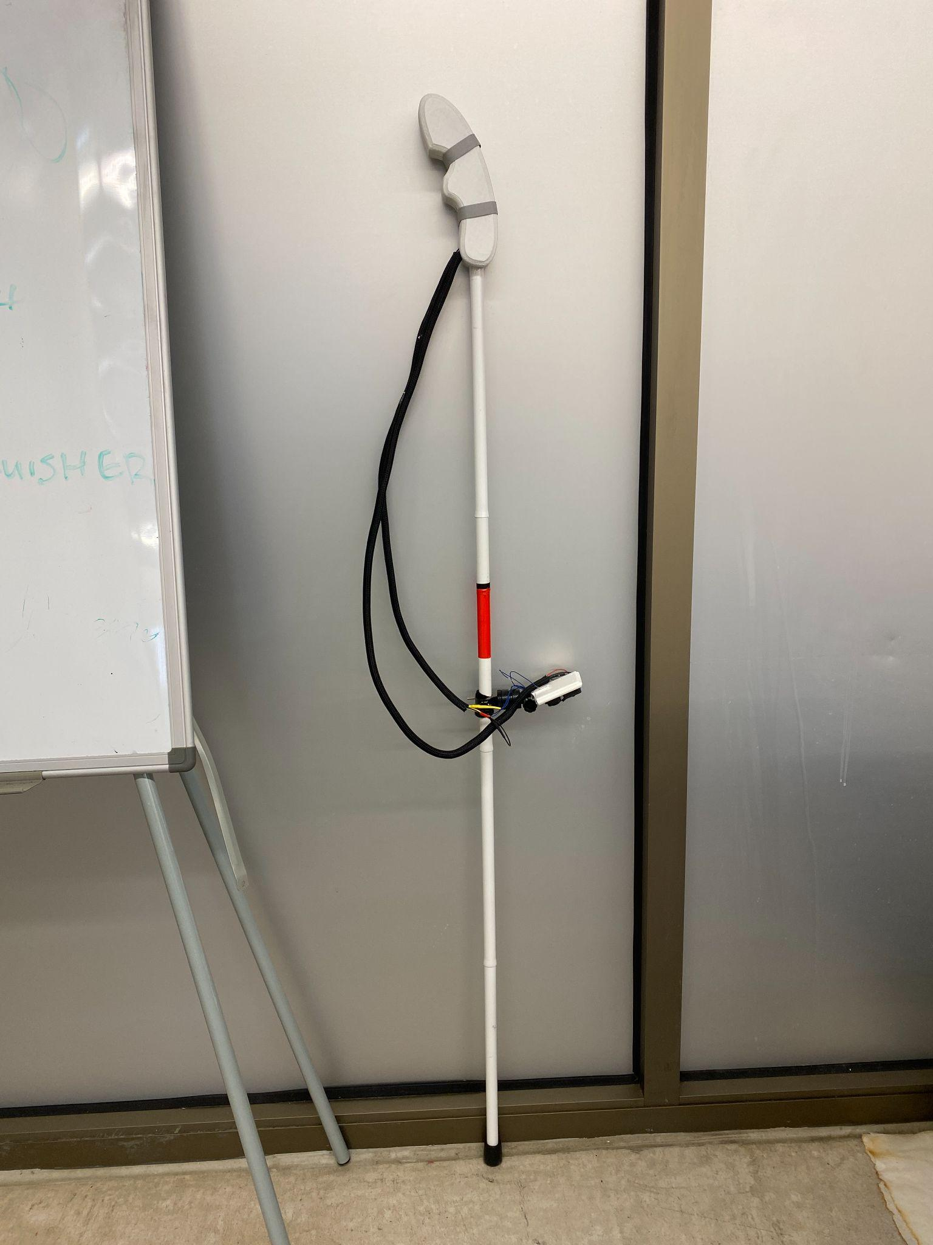

The image above shows the front profile of GUIDE. In this profile you can see the two sensors mounted on the 3D printed sensor mount.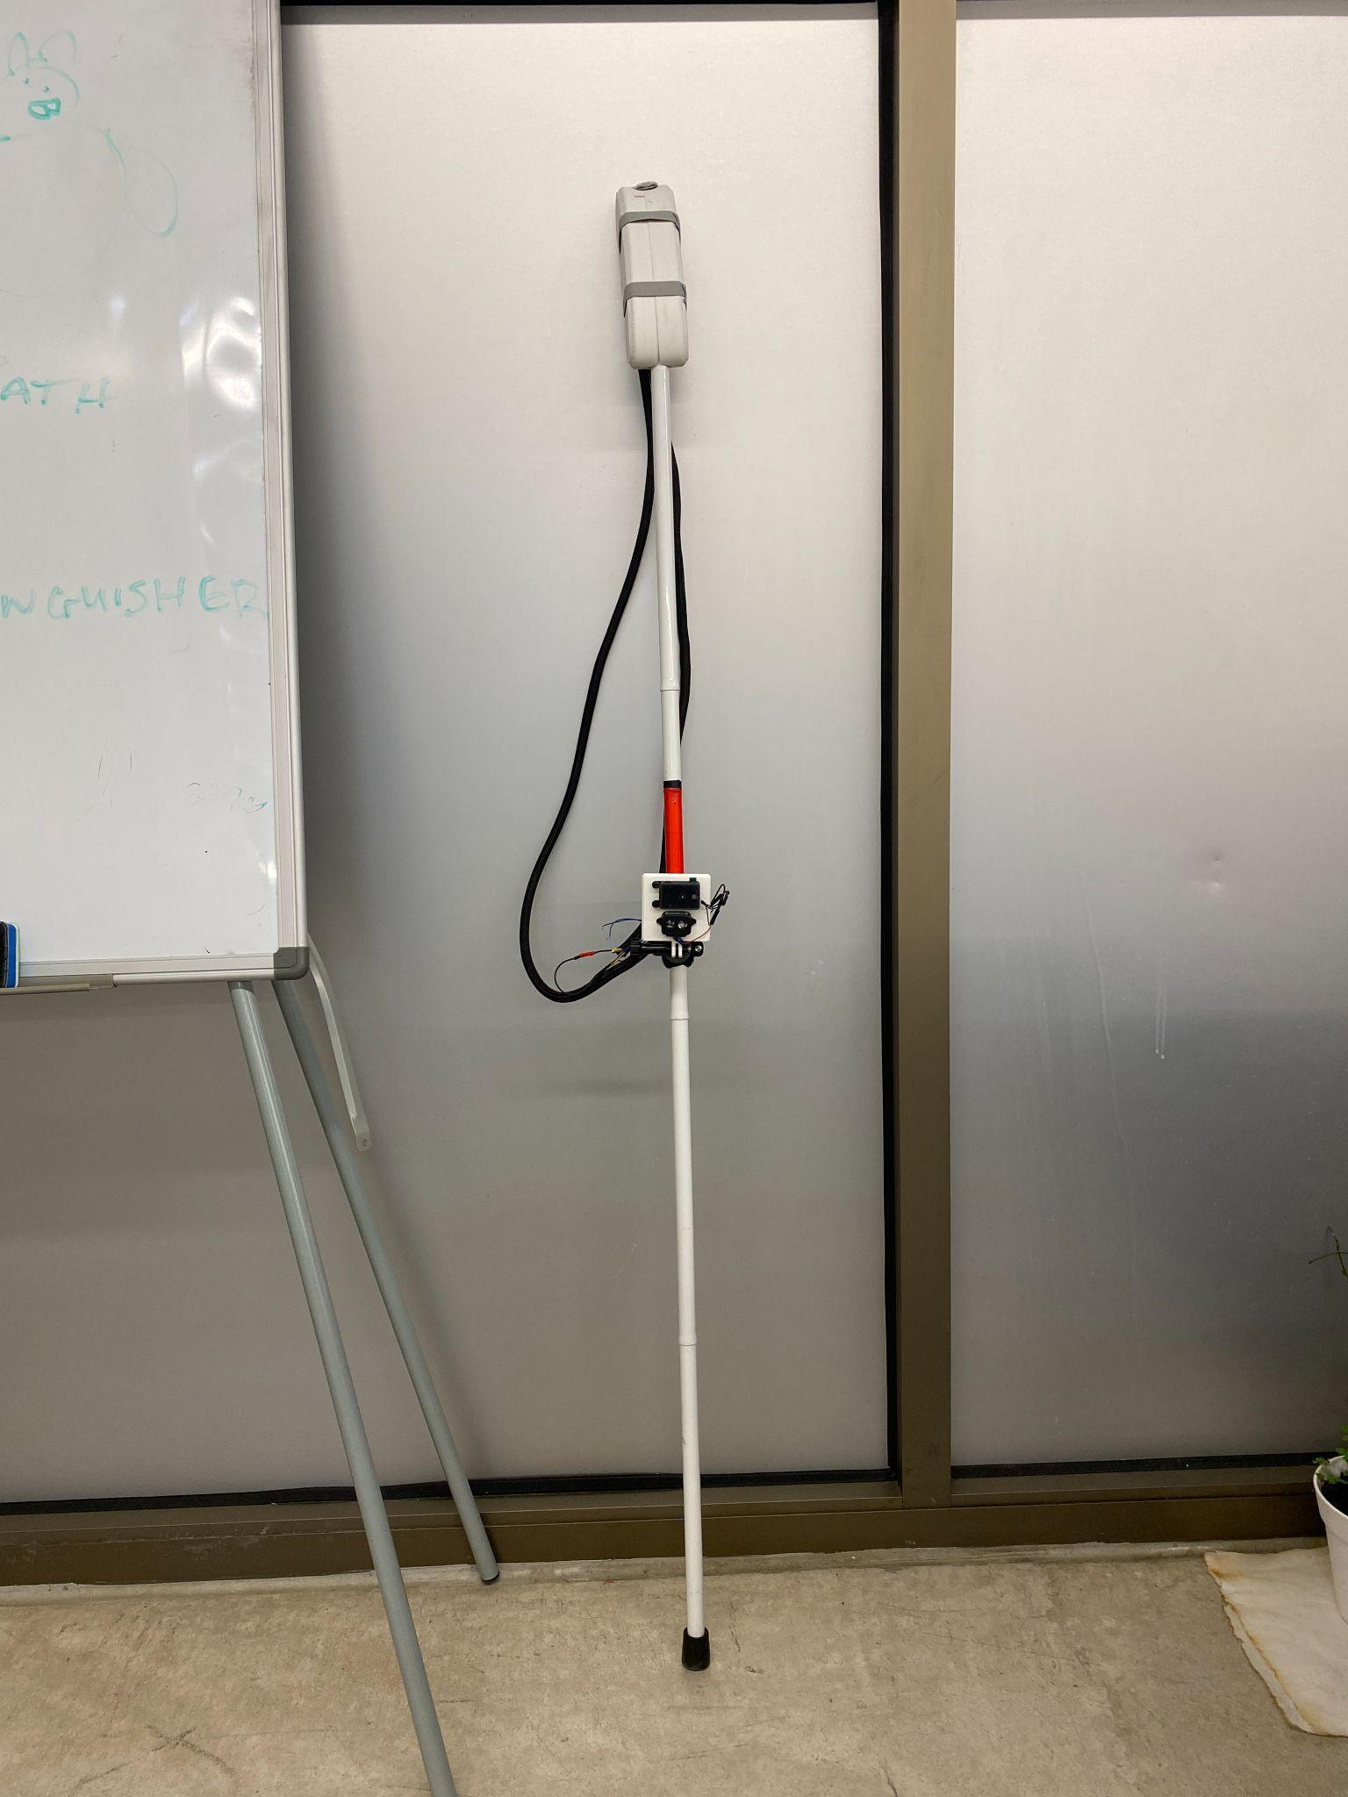

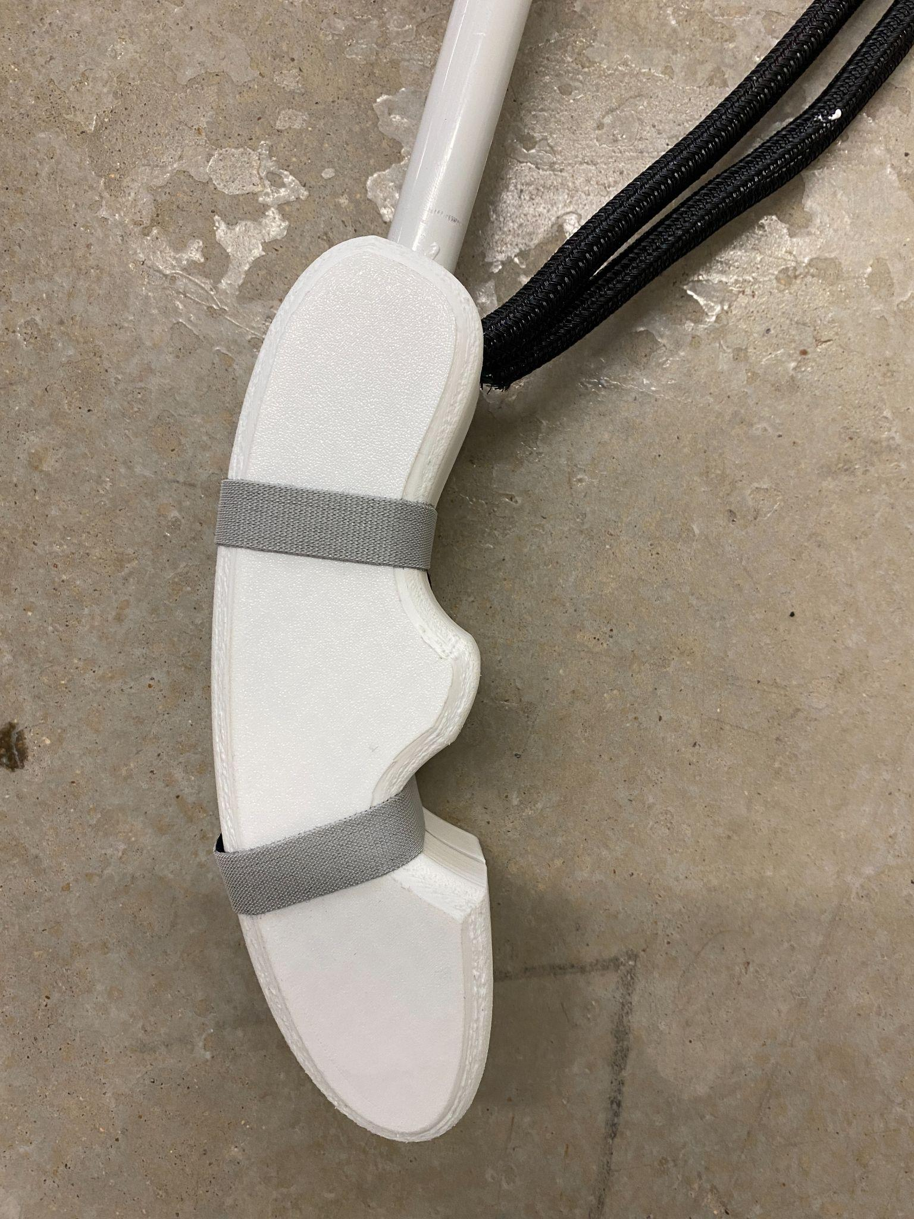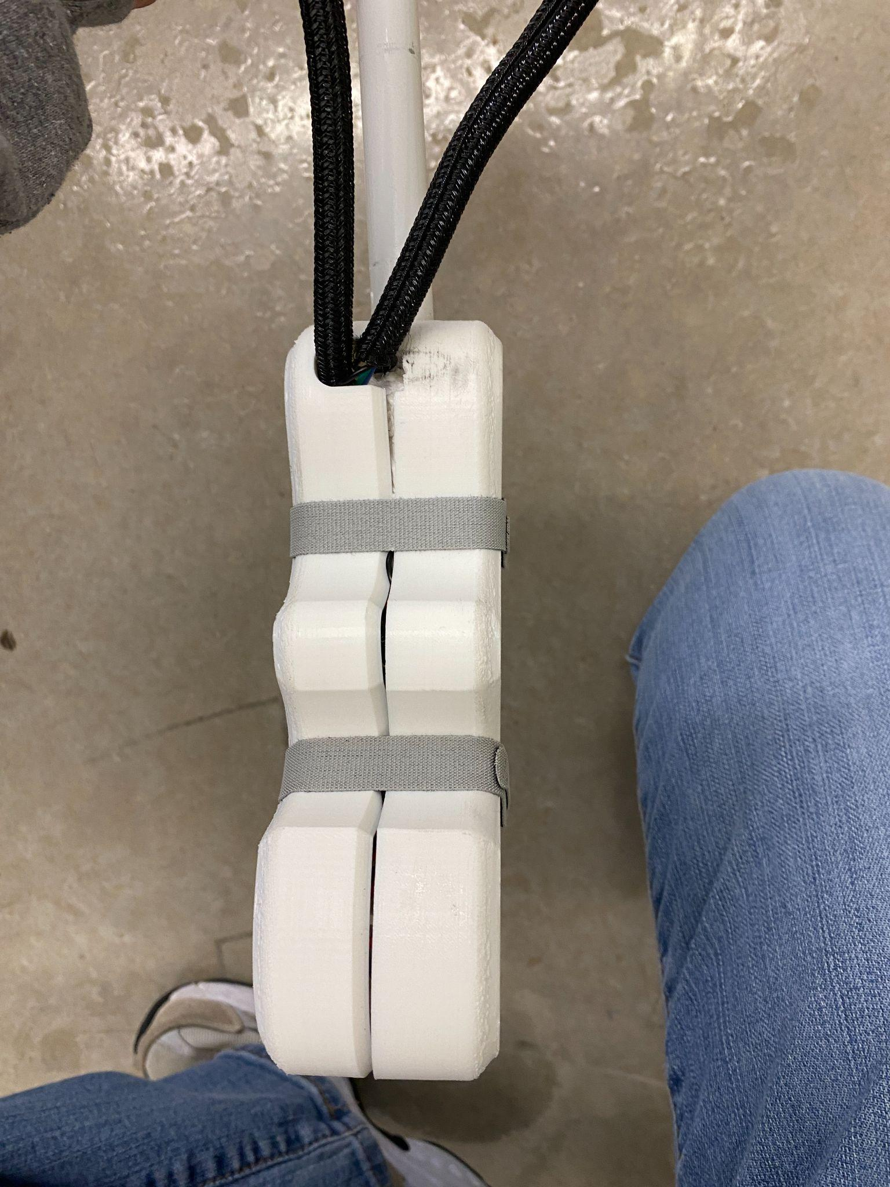

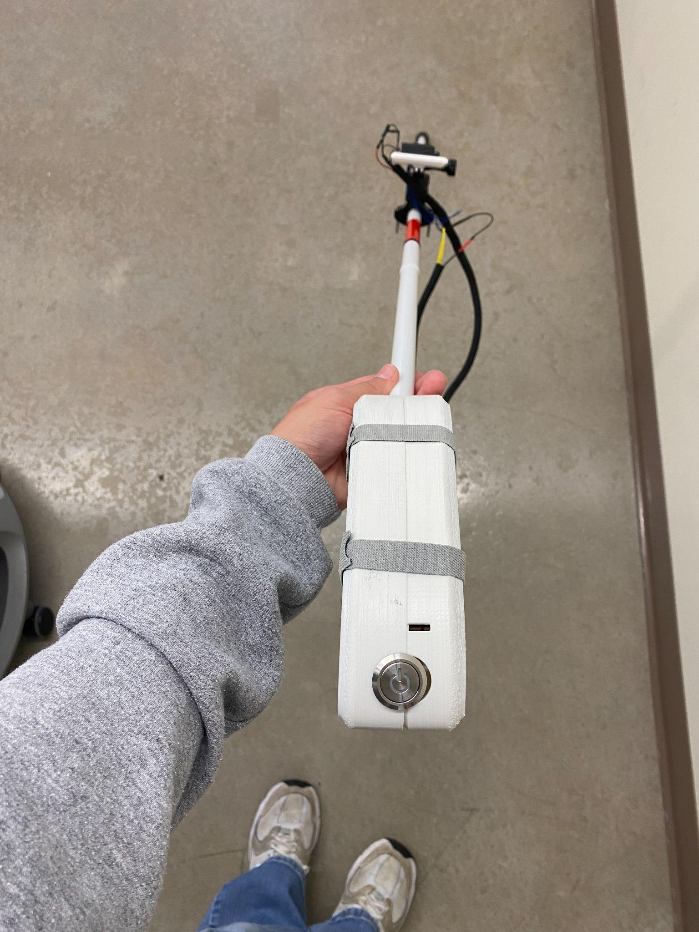

The three images above show close up images of the GUIDE handle. The handle is 3D printed using PLA filament. It houses the power button, buck converter, microcontroller, battery, and haptic sensors. We attached the handle using a foam insert inside and velcro straps. This design was necessary as developers needed to access the inside of the handle.

The two images above show the sensor mount of GUIDE. The sensor mount was developed and 3D printed using PLA filament. The mount is attached to a commercially available camera angle adjuster. On the mount we attached the depth camera on top and the LiDAR below. 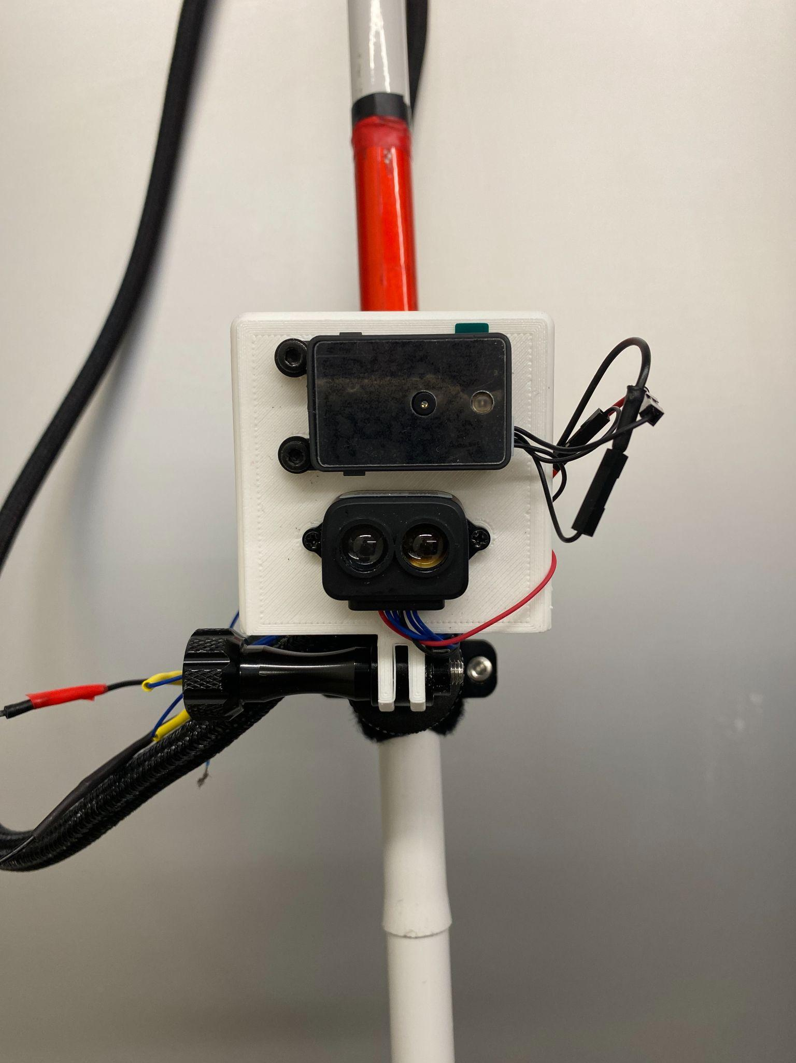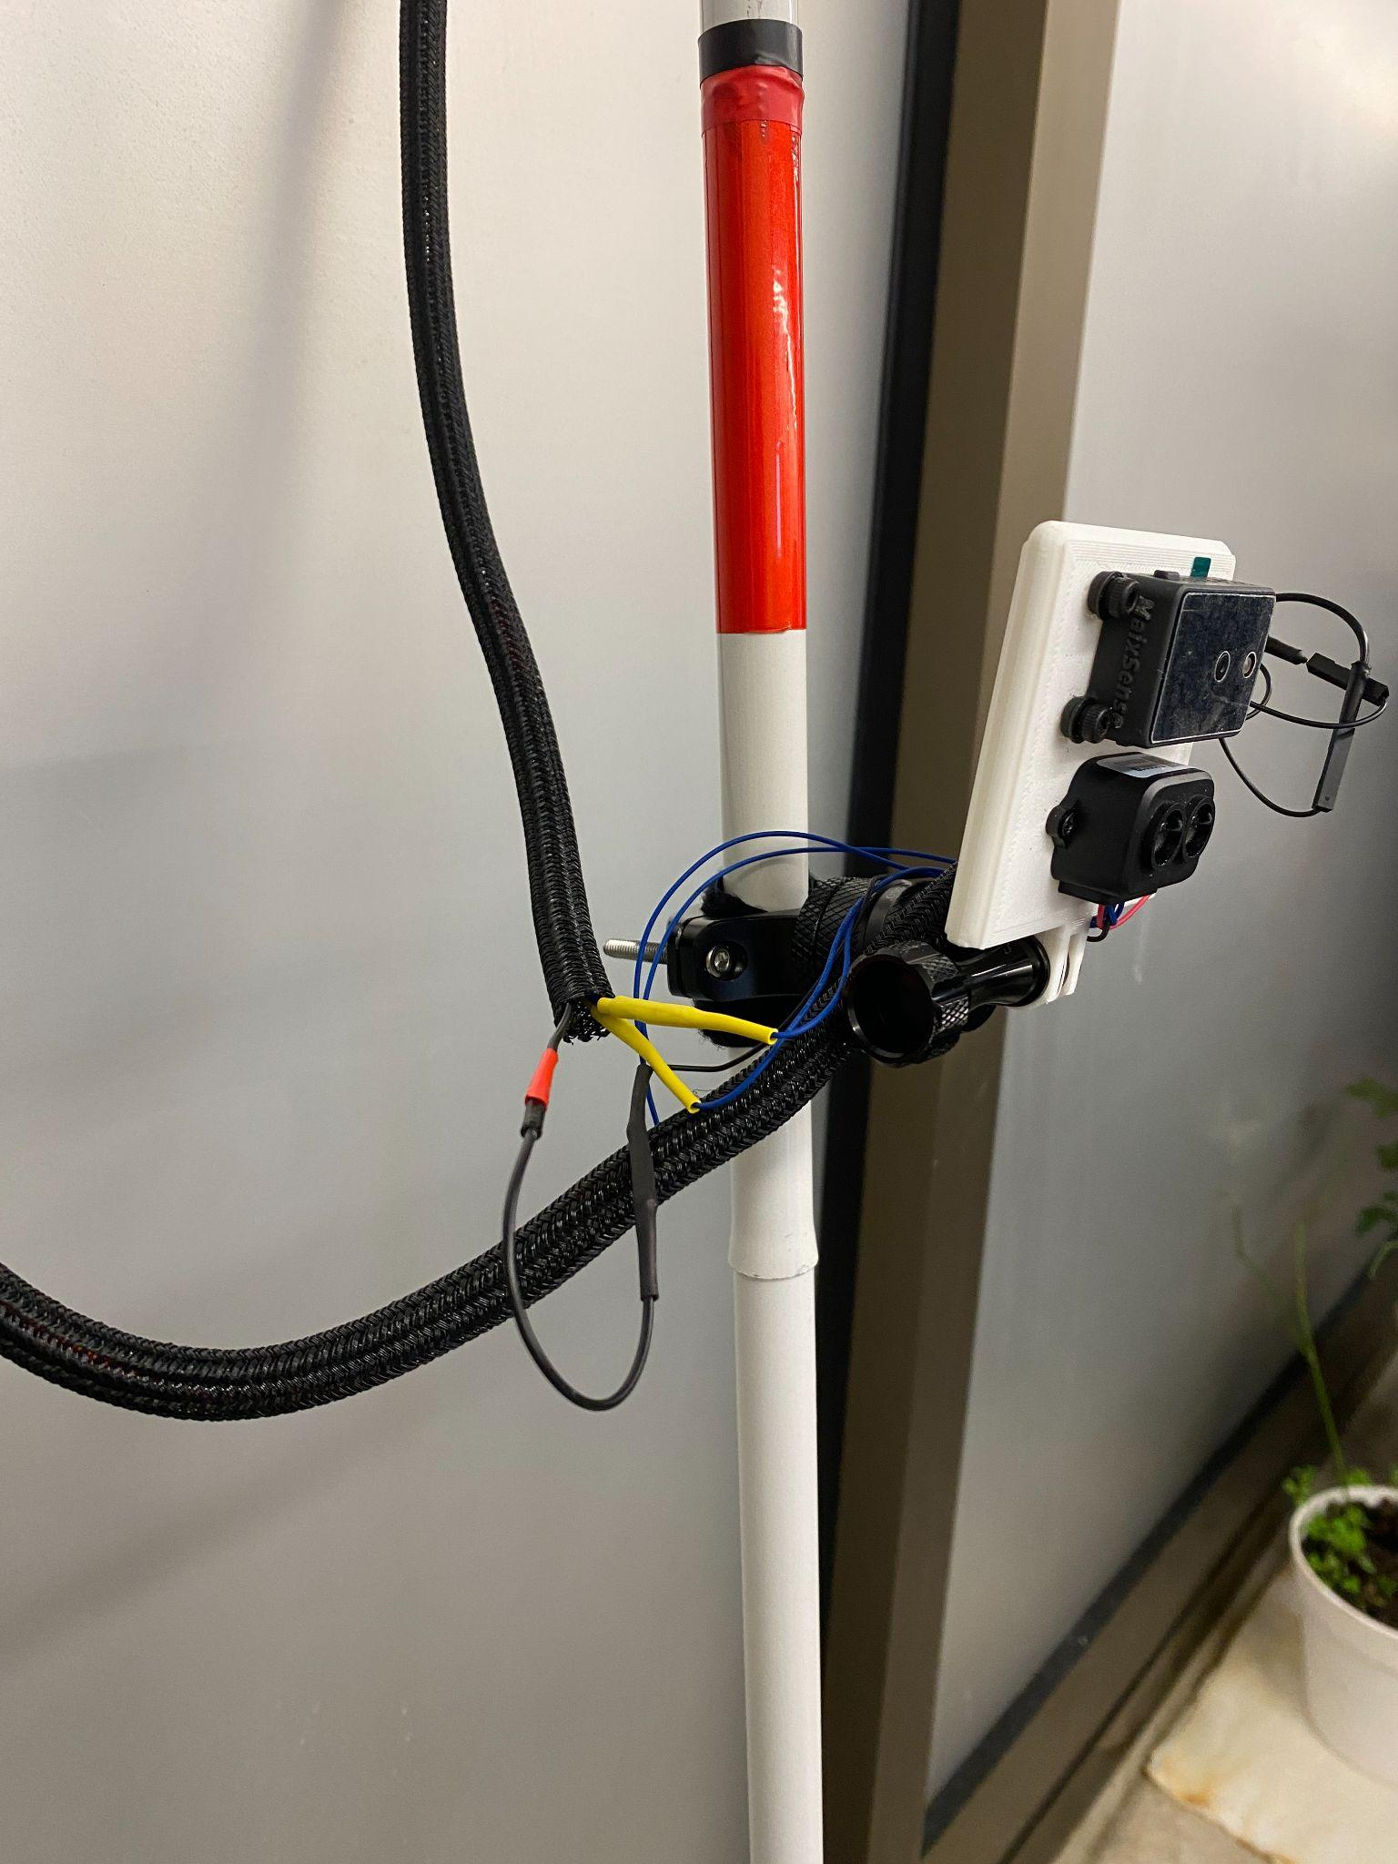

# User’s Manuals

Title: User Manual

Guidance Utility for Impaired Daily Experiences (GUIDE)

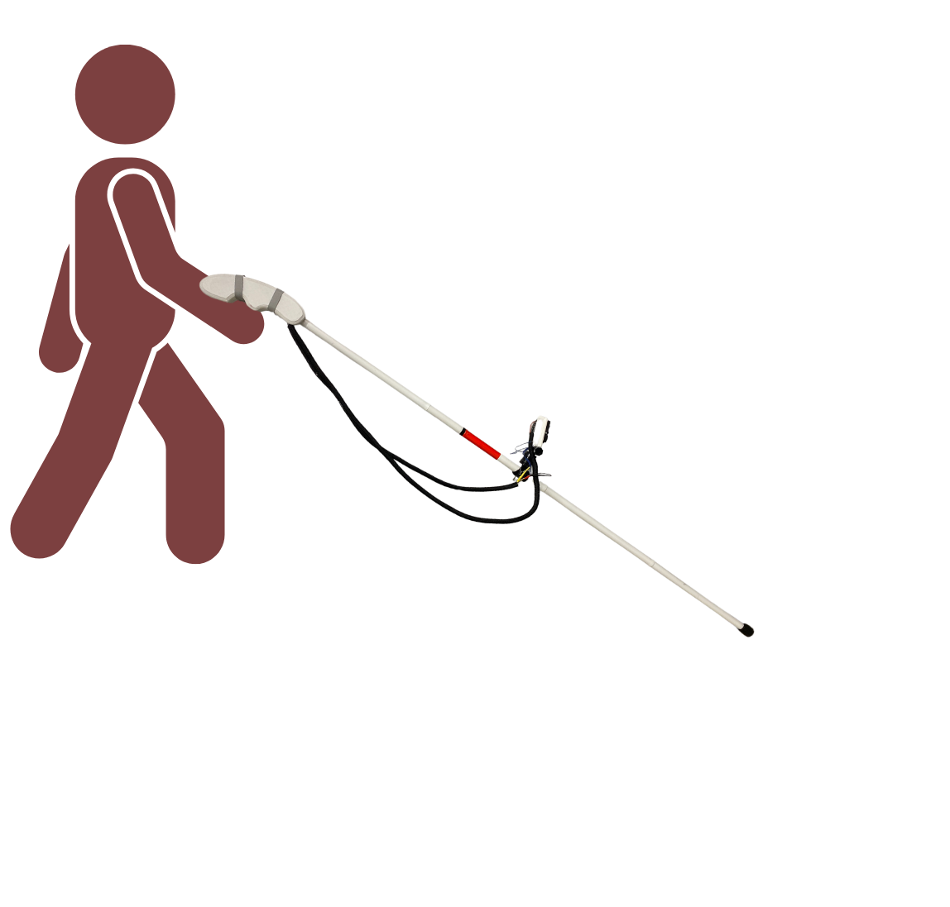

Introduction:

GUIDE is an easy to operate walking stick for those with visual impairments. This innovation of the current white walking stick includes added 21st century electronic sensors and algorithms that enable obstacle detection. The user can feel vibrations on the handle when there is an obstacle at 2m distance away. The vibrations become more intense as the user moves closer to the obstacle. The average GUIDE user has the characteristics below:

* Ages 7+

This is due to the fact that most traditional walking sticks are introduced between the ages of 7-10.

* Any gender
* All levels of visual impairment

GUIDE provides a broader scope of the users environment and can be helpful for anyone with any kind of visual impairment.

* Any height

GUIDE provides an angle adjustable mount where the sensors are located. This allows for the obstacle detection to be adjusted based upon the height of the user as well as at what angle they hold the walking stick.

* All levels of physical activity and strength

GUIDE weighs a total of 1.8 lbs, it is incredibly lightweight and adds less than a pound to the original walking stick. Its lightweight nature allows everyone regardless of fitness level, to be able to use GUIDE.

* All levels of technical expertise

Although GUIDE has various sensors and is powered by python algorithms, the user will not need to interface with these components. GUIDE is powered by a power button, this is the extent that the user will need to interface with the GUIDE components.

Given the current design of GUIDE, no technical expertise is required to set up, utilize, or maintain the walking stick. The user interfaces with GUIDE when recharging their battery via usb-c charging. GUIDE is powered by a 9V commercially available battery. Additionally, the user will press a power button located on the GUIDE handle to turn the added features of GUIDE on and off. GUIDE remains collapsable which makes it portable and easy to use for the user.

GUIDE is intended for individuals with any kind of visual impairment who seek enhanced mobility and a deeper understanding of their environment as they walk both indoors and outdoors. GUIDEs intuitive feedback system allows users of all ages, gender, technical expertise, height, and weight to utilize the full feature suite of GUIDE.

## Hardware Installation

Step 1: Unpack the GUIDE Walking Stick

In your package you will find:

* GUIDE walking stick with handle attached
* GUIDE sensor mount with LiDAR and Depth Camera attached
* USB-C charger cable
* GUIDE handle attachment
* GUIDE user manual

Warning: Make sure you are careful with the GUIDE components as you unpack. Any scratches or damage to the sensors can decrease GUIDEs functionality.

If you run into any issues with the hardware you receive in the package or are missing anything please contact GUIDE.

Phone:

Email:

Online Chat Assistance:

Step 2: Assembling the Walking Stick

To assemble the GUIDE walking stick please ensure the walking stick and handle are connected. At this point you can check for overall functionality by pressing the power button on the end of the handle. If you receive vibrations from the handle, your walking stick is fully operational. You will feel this same vibration sequence when you power GUIDE on. Turn GUIDE off by clicking the power button again. You will receive another sequence of vibrations, this sequence will vibrate every time you power GUIDE off. The image below shows the location of the power button on the handle, simply press this to complete the steps outlined above.

Next, you will need to take the sensor mount and attach it to the angle adjustable ring located mid way through the walking stick. Note the two extrusions on the sensor mount and the two hollow inserts on the angle adjuster located halfway through the walking stick. The images below show the two extrusions on the GUIDE sensor mount and the expected angle adjuster on GUIDE you need to insert into.

To insert, simply unscrew the side twister on the angle adjuster until the hollow inserts are open. Slide in the GUIDE sensor adjuster. Screw in the side twister until tight. Ensure you still have some motion to test GUIDE before operating.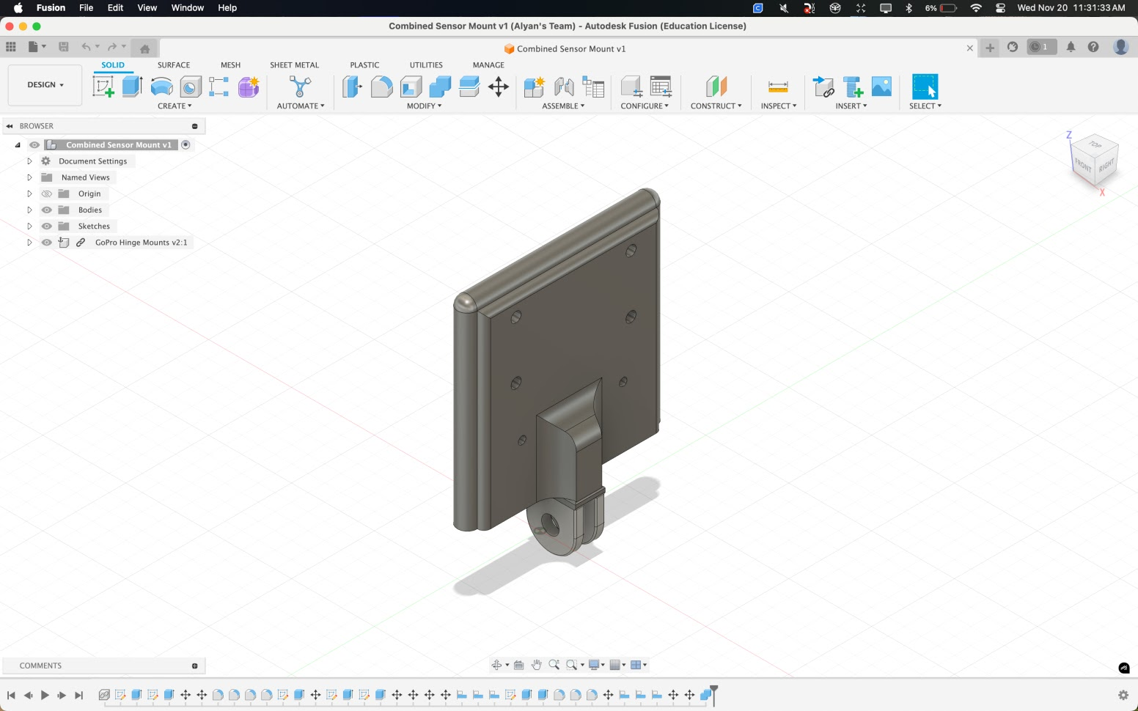

Step 3: Charging GUIDE

GUIDE has a 9V rechargeable battery that is rechargeable with a USB-C cable. In your GUIDE package you will find a USB-C power cable. On your GUIDE handle you will find a cut out where you can insert the charging cable. Once you insert this cable into the handle, attach the other end of the cable to a charging cube. The 9V rechargeable battery takes approximately 1 hour to completely recharge.

To check if your battery needs charge simply power on GUIDE using the power button. If you receive no vibrations then your battery requires charging. To check if GUIDE has powered on, simply power it up using the power button and check for vibrations. Ensure these vibrations are strong and are in similar strength to the typical vibrations.

Step 4: Testing Hardware

The last step in completing the hardware installation is to test if all the components are working. If GUIDE is fully powered on and the sensor mount is attached to the angle adjuster hold GUIDE in the same position you would as if walking. Place your hand in front of the sensors and wait for vibrations. If you are feeling vibrations, GUIDE is calibrated, you may have to wait around 3 seconds to receive vibrations.

Walk around your area and ensure you can feel vibrations around areas you are aware of obstacles. If needed, adjust the sensor mount to a more desirable angle for obstacle detection.

The images below show the final hardware set up of GUIDE as well as a close up of the sensor mount you are able to adjust.

# 

## Software Installation

All of the software needed to operate GUIDE is already installed on the microcontroller located within the GUIDE handle. No further action is required to ensure software is installed.

When you test GUIDE, if you are not receiving an vibrations or it suddenly stops, please contact the following:

Phone:

Email:

Online Chat Assistance:

## Operation Instructions

Step 1: Power GUIDE

To operate GUIDE simply press the power button located on the end of the handle closest to you. When the button is pushed in you should feel vibrations in the handle. Once you feel the sequence of vibrations, the walking stick is available to use.

Step 2: Using GUIDE

Hold the handle in the most comfortable position for you with the walking stick in front of you. Move the walking stick side to side using your arm while walking through the space around you. When walking around using GUIDE in front of you, ensure you can feel the vibrations in the handle. As you get closer to the obstacles you will feel an increase of intensity in the vibrations starting from 2m, to 1m, to 0.5m.

GUIDE is functional both indoors, outdoors, all times of day, and in all weather conditions. All of GUIDEs features are usable in every condition and area.   
  
In the case where GUIDEs features are not responsive and/or require charge you are able to use the walking stick as a traditional white cane for the visually impaired.

Step 3: Troubleshooting

For issues regarding GUIDE responsiveness and usability:

* Check battery life and recharge if necessary
* Clean sensors with a cloth
* Wave your hand in front of the sensors and check for any vibration at any frequency

In the case where GUIDEs features are not responsive and completing the troubleshooting steps outlined above do not yield results please contact the GUIDE helpdesk for assistance:

Phone:

Email:

Online Chat Assistance:

Step 4: Safety Tips

To ensure GUIDEs longevity and usability please keep these safety tips in mind:

* Check for software updates sent by the GUIDE team
* Do not submerge GUIDE in water
* Do not keep GUIDE in hot/humid conditions for a prolonged period of time
* Do not keep GUIDE in cold/freezing conditions for a prolonged period of time
* Ensure GUIDE is fully charged in case of an emergency

Conclusion:

Thank you for choosing to use GUIDE for your everyday experiences. If you encounter any issues while utilizing GUIDE please reach out to the contacts provided in this manual.

Thank you!

# Course debriefing

Our team management style gave quite a lot of freedom to everyone in the group. We did still have a traditional hierarchy: Diana as team leader and software support, Jack L as hardware lead, Jack C as software lead, Ryan as hardware support, Alyan as hardware support, and Noah as software support. However, these roles were not enforced in a strict manner. Lots of discussion regarding decisions to build the product occurred, and the final say was based on credibility and evidence over title ranking. As the team leader, Diana was always on top of any documents or upcoming due dates that the team needed to be aware of. If we did this project again, it could be for the rest of the members to also help keep track of these things so that the team leader would not have to shoulder the entire responsibility alone. Other than that, our team management was very efficient and flexible, and we did not encounter any problems at all. The team leader gave the technical leads autonomy to make decisions and make decisions they felt was best for the project. The hardware lead made decisions over what components were best to purchase and delegated tasks to the hardware support. The software lead made decisions over the overall architecture of the code and which tools, language, etc to use. When the integration phase began and throughout the entire development stage, the two leads worked together to ensure a smooth integration. The overall team leader ensured communication was occurring and if any details were not ironed out, prompted conversations. Overall, our team worked well together and completed all tasks for this project. If anything could have been improved is making a set of backlog tasks needed to complete for the entirety of the project and assigning everyone to them.

In terms of safety, we wanted to ensure none of the things we created would cause harm to the user using our product. In addition to rigorously testing our circuits to make sure it was always safe, we also put everything inside non-conductible materials so that even if current escaped, it would not come in contact with the user. We took care of making sure all wires were covered with non-conductible materials like electrical tape, so that even if wires from different parts of the circuit touched each other, the current would not be able to jump between the wires. Even wires that were dangling out of the handle casing were in cased with non-conductible wire coverings. This makes sure the wires never come in contact with the user, and also makes sure the wires don’t snap from any kind of situation. Additionally, we included zip ties around those dangling wires so that they would not be dangling, but instead be attached to the handle. This again ensures that nothing gets tangled between the wires and the cane, increasing the safety of both the user and the wires.

In terms of ethical concerns, we wanted to make sure everything we used was safe for the environment. Every material we used could be taken apart and be reused if necessary. To deliver a good experience to the user, we did not want to impact their senses that they would be using to navigate the streets. We realized that many people who use a blind walking cane rely on their hearing to know what is happening around them. If we had decided to use sounds to alert the user, it would be difficult for the user to hear all the other things going around them. We decided to use vibrations in the handle to alert the user instead, making sure that our product would be an upgraded version of the blind walking stick, not a detrimental version that blocked their needed senses. Additionally, we made the switch from regular disposable 9V batteries to rechargeable 9V batteries to decrease the amount of waste produced by GUIDE over a period of time. Additionally, we ensured all of the materials used for GUIDE were relatively inexpensive to ensure all members of society could afford our product.

The additional steps that could have been taken to further improve GUIDE was increased research on what kind of machine learning models we could use to enhance the decisions made by GUIDE. By researching potential AI and machine learning solutions, we could have enhanced GUIDEs functionality and created a “smarter” solution. Additionally, making decisions based upon what vibration motors we used could have enhanced the type of vibrations and creativity we had with our final prototype and the haptic feedback given to the user. Our team made decisions based upon staying within our set requirements of keeping the design lightweight and compact. However, as a collective we could have spent more time researching the full range of electrical components at our disposal and making the best decision for GUIDE while staying within budget and constraints.

Although we had contacted a disabilities center to ask if we could test our product with the people there, we never got a response from them. However, through our own testing, our product works as it was proposed. Although we initially brainstormed a lot, we figured out what we could and could not do given the amount of time we had as well as the amount of budget we had. In the end, we decided on a few constraints that our product needed to achieve. The sensor must sense up to two meters ahead, the weight of the cane must be less than two pounds, and the feedback time it takes from the sensor detecting an object to the user receiving the vibration must be less than 0.5 seconds. Although we had more, these three were the main constraints we had, and we were able to pass them all. Our product was made to be usable anywhere at any time. The sensors do not rely on light to work, meaning that the stick works even at night. Our product is also light to intend to be used anywhere for however long, from the college campus, to mountainous ranges. Although we have not tested the stick outside of the college campus, we are extremely confident that it would still work the same. Also because we did not over build the blind walking cane, even without the additional features we added, the stick would work perfectly fine. This ensures that there is not a learning curve to using our product for any individual who would want to use it over a regular blind walking cane. If we were to do this project again, we would definitely include more places for testing and verifying that our product works as intended anywhere and everywhere. We would want to test smaller spaces with irregular floor shapings, such as a small ramp for wheelchairs, stairs, or handles stuck to the ground.

The intended environment of GUIDE was a college campus. We were able to test GUIDE inside, outside, and in public spaces. A variation of the testing environment that was not taken into consideration was different weather conditions. In the rain, electrical components could become affected and render GUIDE completely ineffective. To ensure GUIDE was waterproof, we would need to completely encapsulate all of the internal components and ensure it was secure with no room for water leakage. This waterproof feature is important as College Station in particular can be very humid and rainy, the disruption of weather would not be good for GUIDE accessibility. Additionally, GUIDE could have been tested for a prolonged period of time walking throughout campus. A useful use case could have been having a member of our team utilize GUIDE throughout their day on the Texas A&M campus. The student could walk through the campus to all of their classes, through the buildings, and around the large number of students on campus.

Overall, CSCE 483 was a very great experience where we got to test everything we had learned within the past 4 years of our degree. We utilized what we learned from software practices, electronics knowledge, system design, and so much more. In this Computer Engineering course we were able to merge both software and hardware to create GUIDE and apply the theories we learned. This course also taught us a great deal about teamwork and how to work with others to achieve a common goal. In our futures, we will most likely work with a team and other engineers. This project helped us understand how to best convey our ideas, perspectives, and communicate effectively. Apart from the technical aspects, our team attended the CSCE Industry Expo where we were able to communicate with industry professionals and answer any questions that arose. As speakers and presenters, our team has grown since the first proposal presentation. We learned how to speak clearly and be descriptive. Conclusively, this course has provided the team with a means of testing our technical knowledge as well as social skills of presenting and communication.

# Budgets

Summarize the costs of the prototype, including parts list with sources, and any support tools required (with costs.) Provide (1) detailed cost breakdowns, (2) a short narrative summarizing the costs, and (3) a comparison of these costs with the proposed budget and with your estimate of the cost in mass production.

Proposal Parts List

| Part Type | Amount of Units | Vendor | Cost | Total Cost |
| --- | --- | --- | --- | --- |
| Walking Stick | 1 | Amazon | $17.99 | $17.99 |
| Power Button | 1 | Amazon | $9.99 | $9.99 |
| Vibrating Motor | 2 | Amazon | $7.59 | $7.59 |
| RPLiDAR | 1 | Amazon | $99.00 | $99.00 |
| Depth Camera | 1 | Owned | $43.00 | $43.00 |
| Lithium Ion Battery | 2 | Amazon | $12.99 | $12.99 |
| Supulse Battery Charger | 1 | Amazon | $12.99 | $12.99 |
| 3D Printing Service | - | FEDC | $1/hr + weight | $60 max |
| Soldering Kit | 1 | Amazon | $9.98 | $9.98 |
| Screws & Bolts | 1 | Amazon | $14.85 | $14.85 |
| Screwdriver Set | 1 | Walmart | $8.48 | $8.48 |
| Breadboard | 2 | Owned | - | - |
| Wire Spool | 1 | Amazon | $24.59 | $24.59 |
| Raspberry Pi Pico 2 | 2 | Amazon | $12.50 | $12.50 |
| TOTAL | $230.86 | | | |

Final Parts List

| Part Type | Amount | Amount per Unit | Cost per Unit | Dimensions | Weight | Total Amount ($) | Source |
| --- | --- | --- | --- | --- | --- | --- | --- |
| Walking Stick | 1 | 1 | $17.99 | 53in x 0.5in - Rod  7in x 1in - Handle | 0.55lb | $17.99 | [Amazon](https://www.amazon.com/Folding-Mobility-Marshmallow-Visually-Impaired/dp/B08DJFZQKF/ref=sr_1_1_sspa?crid=F9U5NC8RIFNU&dib=eyJ2IjoiMSJ9.K3FA4VqzQPhEGvdID-Uub0GuUf5lxcrWzXPW9GCkEaCYmN0mtbFOgGRN9DunGNval5RFBhH7kPqupN58wvk7z9EkEunuBF9jxhSaZASn7bHyGE9t6MDDC4F1imylM20FYvXtmEMEUkaDglW24iQqyPlQjyaaGGmHGErgVdNJytWgjJDWCPQdRQZHKCPOcTIX.tzEM_Hj8DBoDP-gDiPYu4m1yiQ87KHg_QO3FDGb01qU&dib_tag=se&keywords=visually+impaired+stick&qid=1725827476&s=sporting-goods&sprefix=visually+impaired+stick%2Csporting%2C192&sr=1-1-spons&sp_csd=d2lkZ2V0TmFtZT1zcF9hdGY&psc=1) |
| Power Button | 1 | 1 | $9.99 | 16mm | 0.35 ounces | $9.99 | [Amazon](https://www.amazon.com/dp/B07RY7P6HM/ref=sspa_dk_detail_3?pf_rd_p=8c2f9165-8e93-42a1-8313-73d3809141a2&pf_rd_r=158NZ54FQAFYTQBKZR31&pd_rd_wg=InOdC&pd_rd_w=fQLZX&content-id=amzn1.sym.8c2f9165-8e93-42a1-8313-73d3809141a2&pd_rd_r=b4a56b68-d1fb-448d-ad5e-2fd998429bf6&s=industrial&sp_csd=d2lkZ2V0TmFtZT1zcF9kZXRhaWw&th=1) |
| Vibrating Motor | 2 | 8 | $7.59 | 10mm x 2.7mm | 0.63 ounces | $7.59 | [Amazon](https://www.amazon.com/ZYAMY-12000RPM-Vibration-Electronic-Adhesive/dp/B07P9Q8LNQ) |
| LiDAR | 1 | 1 | $23.99 | 10mm x 2.7mm | 0.176 ounces | $23.99 | [Amazon](https://www.amazon.com/dp/B088NVX2L7?ref=ppx_yo2ov_dt_b_fed_asin_title) |
| Depth Camera | 1 | 1 | $43.00 | 10mm x 2.7mm | 10.6 ounces | $43.00 | Owned |
| Buck Converter | 1 | 6 | $1.67 | 22mm x 17 mm | 3g | $10 | [Amazon](https://www.amazon.com/dp/B01MQGMOKI?ref=ppx_yo2ov_dt_b_fed_asin_title) |
| Raspberry Pi Pico 2 | 2 | 2 | $6.25 | 21mm x 51mm | 4g | $12.50 | [Amazon](https://www.amazon.com/Raspberry-Pi-Pico-RP2040-microcontroller/dp/B092S2KCV2/ref=sr_1_8?crid=2N6BKB08PKXKA&dib=eyJ2IjoiMSJ9._QBOIpt8AqZvKLFCq3SFTJWibKUF5trt6rPXKjWUHcW0nj1JWlEelyPTW7gNP6QNGlOPRzk9LqkdG8flW9TXghjIwUXn9maRPfrbxAHvXAgDKY6rMGvfGvRZWKCfA7m4azP7RTz9QY1ZJom4Fd2-fTVt4mEI9stHYiF2Vm5TXfrOS_aZ67N6pMlre1aIqzSGznkbtqKCx9Q28dLFEZ-Mq0eYwJA7XkVV8wMqLlYrdTNgSukUTCX3LdkHA2rycRbuJhnYGRy2WXbYYSIh8ueznPyyjpaOusy-O7wetTxIKBA.MBaTnNokI6dI5gJNZ8GEVAlwTN7-BWMaN9BG0UKgyE4&dib_tag=se&keywords=raspberry%2Bpi%2Bpico%2B2&qid=1733096800&s=electronics&sprefix=raspberry%2Bpi%2Bpico%2B2%2Celectronics%2C126&sr=1-8&th=1) |
| 9V Battery Holder | 1 | 10 | $0.50 | 0.94"L x 0.47"W x 0.28"H | <1g | $4.99 | FEDC |
| 9V Battery (Rechargeable) | 1 | 4 | $5.25 | 48.8mm x 26.0mm | 0.12kg | $20.99 | [Amazon](https://a.co/d/gwD6N9r) |
| PLA Printer Filament | 1 | 1 | $0.055 (per g) | N/A | 63g | $3.50 | FEDC |
| Angle Adjuster | 1 | 1 | $13.99 | 2.95” x 2.56” x 0.98” | 0.09kg | $13.99 | [Amazon](https://www.amazon.com/dp/B07SR2XNJQ?ref=ppx_yo2ov_dt_b_fed_asin_title&th=1) |
| Total (s) | N/A | N/A | N/A | N/A | 44.72 oz or 2.795 pounds | $168.53 |  |

As shown above, there have been a few changes to the budget throughout development. The change of the LiDAR had the most impact on the budget, as the LiDAR from the proposal was over $70 more expensive compared to the TF2-Luna used in the final design. Due to the lowered budget constraints from this decision, this allowed greater flexibility in changing parts throughout the development period, although without this change the final budget would still be under $300. Additional changes include a new rechargeable battery and an angle adjuster.

The cost to mass-produce this product would decrease compared to the prototype. Many items on the final budget list were purchased in bulk for testing purposes, meaning that the total cost would lower by roughly $15. It is also important to note that a realistic estimate for a mass-production estimate would also include a decrease in price from purchasing parts internally instead of external vendors such as Amazon. A rough estimate for a mass production cost would be roughly $100 due to the total cost reductions from these factors.

# Appendices

Here you can include any additional information not already in the implementation notes (e.g., detailed circuit schematics, class hierarchy) that would help replicate or maintain your implementation.

* [1]"UART: A Hardware Communication Protocol Understanding Universal Asynchronous Receiver/Transmitter." Analog Dialogue, Vol 54, December 2020. Available: https://www.analog.com/en/resources/analog-dialogue/articles/uart-a-hardware-communication-protocol.html
* [2]"How to Solder." Instructables, by noahw, Autodesk, 2024, [www.instructables.com/How-to-solder/](http://www.instructables.com/How-to-solder/).

# References

* [1] World Health Organization, Aug. 10 2023, “Blindness and Visual Impairment”, World Health Organization,[Online],Available: <https://www.who.int/news-room/fact-sheets/detail/blindness-and-visual-impairment>
* [2] Snowflake_tvi, "Lazarillo: A Free Accessible GPS App for the Blind and Visually Impaired," Perkins School for the Blind, Sep. 19, 2024. [Online]. Available: https://www.perkins.org/resource/lazarillo-free-accessible-gps-app-blind-and-visually-impaired/ (accessed Sep. 19, 2024).
* [3] MathWorks, "SLAM (Simultaneous Localization and Mapping)," MathWorks, Sep. 19, 2024. [Online]. Available: https://www.mathworks.com/discovery/slam.html (accessed Sep. 19, 2024).
* [4] I. Papagianopoulos, G. De Mey, A. Kos, B. Wiecek, and V. Chatziathasiou, "Obstacle Detection in Infrared Navigation for Blind People and Mobile Robots," Sensors, vol. 23, no. 16, p. 7198, Aug. 2023, doi: 10.3390/s23167198.
* [5] feelSpace GmbH, "feelSpace naviGürtel," feelSpace, Sep. 19, 2024. [Online]. Available: https://feelspace.de/en/ (accessed Sep. 19, 2024).
* [6] WeWalk, "WeWalk - Brand New Smart Cane 2," WeWalk, Sep. 19, 2024. [Online]. Available: https://wewalk.io/en/ (accessed Sep. 19, 2024).
* [7] Security Robotics, "SPOT – the allrounder," Security Robotics, Sep. 19, 2024. [Online]. Available: https://security-robotics.de/en/allrounder-spot (accessed Sep. 19, 2024).